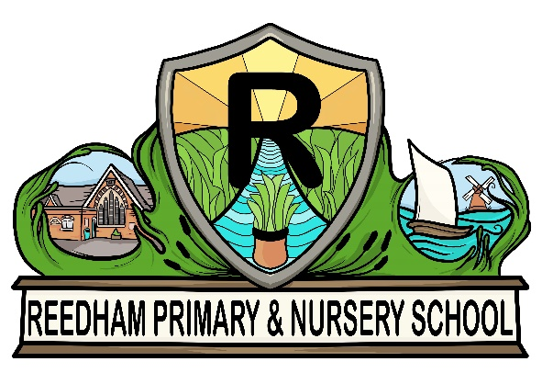

Reedham Primary and Nursery School

PE and School Sports Policy
Working in partnership with Premier Education

Subject Lead: Miss Beth Spaul

Academic Year: 2023-2024

Contents
Intent - School Sport on a Page 2
Whole School vision and ethos: 2
School intent/vision statement for PE and sport: 2
Whole School Sport Improvement Plan Aim/Objectives 2
School Sports Premium Funding Intent 2
School Games and Competitions Intent 2
National Curriculum Intent 3
Implementation 4
Pupil Progression plan 4
Curriculum Overview 7
School PE curriculum 8
Early Years Foundation stage overview 8
Key Stage 1 overview 9
Lower Key Stage 2 overview 9
Upper Key Stage 2 overview 10
Extra-Curricular Overview 12
Impact and evidence 13
Curriculum 13
Objective 1 - Example Pupil attainment 13
Objective 2 - Example Pupil Perception 13
Objective 3 - Example Visibility in school 13
Extra Curricular 14
Provision: Example: Stay Active 14
Provision: Example: After school football club 14
Provision: 14

National Curriculum Intent

Guidance from afPE for the progression within PE was taken into account- along with the national curriculum- when designing our PE curriculum.

Early Years
Expected
Children show good control and coordination in large and small movements. They move confidently in a range of ways, safely negotiating space. They handle equipment effectively. Children know the importance for good health of physical exercise and a healthy diet and talk about ways to keep healthy and safe. Children play cooperatively, taking turns with others. They take account of one another’s ideas about how to organise their activity.
Exceeding
Children can hop confidently and skip in time to music Children know about and can make healthy choices in relation to healthy eating and exercise. Children play group games with rules.

Key Stage One
Pupils should continue to develop fundamental movement skills, become increasingly competent and confident and access a broad range of opportunities to extend their agility, balance and co-ordination, individually and with others. They should be able to engage in competitive (both against self and against others) and co-operative physical activities, in a range of increasingly challenging situations.

Key Stage Two
Pupils should continue to apply and develop a broader range of skills, learning how to use them in different ways and to link them to make actions and sequences of movement. They should enjoy communicating, collaborating and competing with each other. They should develop an understanding of how to improve in different physical activities and sports and learn how to evaluate and recognise their own success.

Intent - School Sport on a Page
Whole School vision and ethos:  Empowering our children and families to flourish and grow. Creativity, compassion, responsibility, the love of learning to gain knowledge and wisdom, combined with Christian values. Together we are stronger, respecting ourselves and others to create a successful and healthy future. | School intent/vision statement for PE and sport:  At Reedham Primary and Nursery School, we strive to create a culture which aims to inspire an active generation to enjoy PE, encourage each other and achieve. We provide a safe and supportive environment for children to flourish in a range of different physical activities which is essential in supporting their physical, emotional, spiritual, social and moral development.

Whole School Sport Improvement Plan Aim/Objectives
1. promote physical activity and healthy lifestyles
2 to observe and demonstrate the conventions of fair play, honest competition and good sporting behaviour as individual participants, team members and spectators
3. embed life-long values such as co-operation, collaboration and equity of play.

School Sports Premium Funding Intent
- Year 6 Sports Leaders lead lunch time clubs for children to take part in
- Premier Education lunch time club – enhanced opportunities for sport at lunch time.
- New equipment to be bought to replace old/broken equipment or to improve on current provision.
- The school offered a sporting after school club every day during the school year. One class from each year group will take place on a half termly basis and swap each half term.
- Pupils to take part in more competitive sport (intra and inter).

Implementation

Pupil Progression plan

 | Reception ⇨ | Year 1 ⇨ | Year 2 ⇨ | Year 3 ⇨ | Year 4 ⇨ | Year 5 ⇨ | Year 6
Team Games  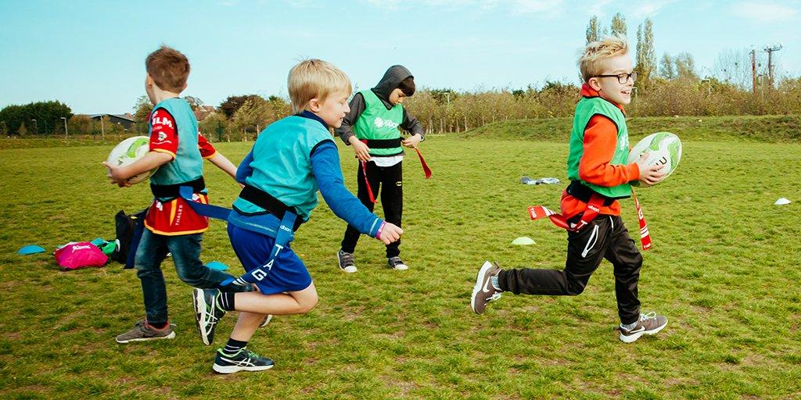 | Fundamentals of Movement  Theme: Handling equipment with control  Coverage: FOM – roll, push, throw,  strike, kick, bounce | Multi Skills  Theme: Multi Skills, spatial awareness.  Coverage:  Agility, Balance,  Coordination. Fundamentals  of Movement (FOM) | Multi Skills  Theme: Working as a team  Coverage: Consolidating fundamental movement skills (FMS) from Year 1 to include, kicking, Trapping, throwing, catching, bouncing, pushing, rolling | Invasion Games  (Football / Hockey)  Theme: Attacking and defending  Coverage: Develop basic rules of these sports through attacking/defending based activities 3v1 4v2  5v3. | Invasion Games  (Football / Hockey)  Theme: Making choices and decisions  Coverage:  Develop sports specific skills for football & hockey. Provide opportunities for children to apply tactics and strategies using 3v2 4v3 5v4 | Invasion Games  (Tag Rugby/Basketball)  Theme: Attacking play  Coverage: Focus on developing attacking principles and goal scoring skills. Further develop sport specific skills and rules. Matches of 3v3 4v4 | Invasion Games  (Tag Rugby/Basketball)  Theme: Teamwork and tactics  Coverage: Consolidate FSS and compete  in matches using clear tactics and sport specific techniques  4v4 5v5 6v6
Dance  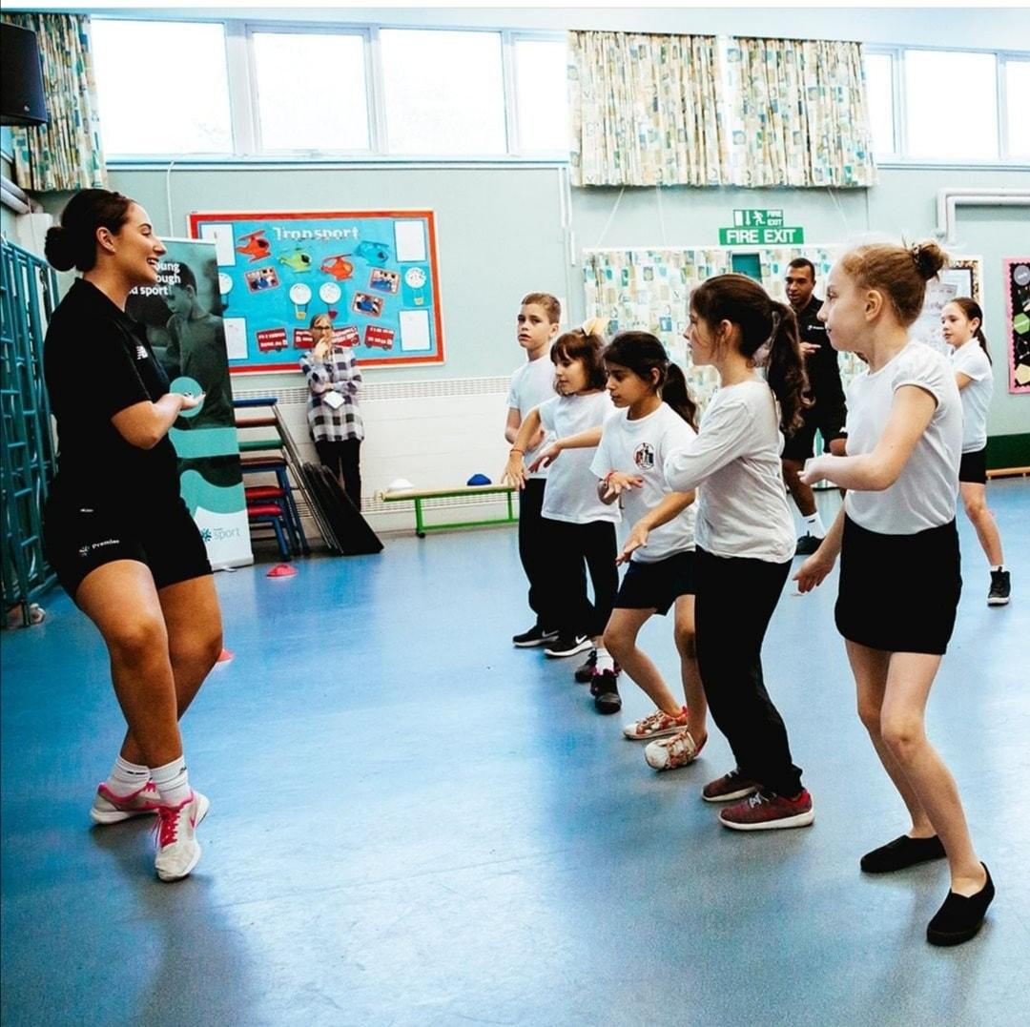 | Fundamentals of Movement - ABC  Theme: Traveling and moving confidently  Coverage: FOM – stillness, jumping, run,  changing shape, direction, hop. Use apparatus. | Dance  Theme:Short stories or story based class/ school theme  Coverage: Shapes and Patterns, Travelling, Change of speed/rhythm/level  /direction (teacher led) | Dance  Theme: Linked to class/school theme  Coverage: Shapes and rhythm. Responding to rhythm. Negotiating space. | Dance  Theme: Science, linked to class/school theme  Coverage: Create and perform a short group dance showing a range of movement patterns | Dance  Theme: Linked to class/school theme  Coverage: Perform a partner dance that includes a range of stimuli that allows performers to react to. | Dance  Theme: Linked to class/school theme  Coverage: Use a cross curricular link to the classes current topic. Perform a whole class dance with small groups each creating a part of the dance, which they teach to their peers. | Dance  Theme: Linked to class/school theme  Coverage: Responding to music/stimuli,  expressing moods and  feelings. Creating simple characters and narrative in movement.
 | Reception ⇨ | Year 1 ⇨ | Year 2 ⇨ | Year 3 ⇨ | Year 4 ⇨ | Year 5 ⇨ | Year 6
Gymnastics  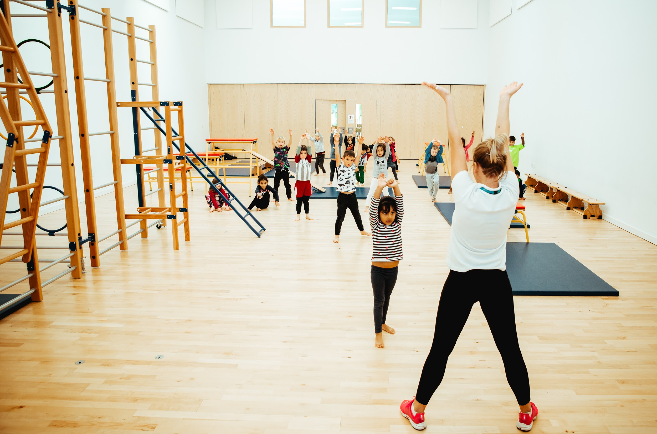 | Fundamentals of Movement  Theme: Combining travelling and handling equipment  Coverage: negotiate space confidently,  and improve ABC’s. | Gymnastics  Theme: Travelling & Balancing, Linking actions.  Coverage: (FSS) Developing Travelling,  Balancing & principles of  finding space | Gymnastics  Theme: Rolling and Jumping, Linking actions.  Coverage: (FSS) Developing Rolling,  Jumping skills and linking  these actions | Gymnastics  Theme: Shapes, jumping and landing  Coverage: Create a sequence using gymnastic floor elements in pairs and/or small groups. Rolling, balancing, jumping  and travelling. Vary direction and levels. | Gymnastics  Theme:Transferring weight  Coverage: Create a small group apparatus based sequence that includes balancing, jumping rolling and travelling. Introduce  more complex skills that focus on transferring weight. | Gymnastics  Theme: Sequences, effective combinations  Coverage:Develop fluency of elements  within a complex sequence. Work in small groups to include contrasting actions. | Gymnastics  Theme: Sequencing, matching and mirroring  Coverage: To create a sequence in pairs using mirror and matching elements using complex apparatus and skills.
OAA | Fundamentals of Movement  Theme: Simple skills of sending/receiving  Coverage: send/receive various equipment using feet, hands, other. Kick, throw, hit, catch, trap, rol | Team Work  Theme: Send, receive and retrieve & teamwork  Coverage: Kicking, striking, catching  (using various equipment) and  working in teams,  co-operation. | Team Work  Theme: Develop FMS.  Developing simple attacking and defending skills for invasion sports (basketball, netball)  Coverage: Working in pairs– Send,  receive and score, based on a  2v1 or 2v2 scenario. | Outdoor Adventurous  Activity  Theme: planning/ recording in different activities and problem solving.  Coverage: Use maps and diagrams to orientate. Plan to  overcome challenges to problems as a group. Identify success. | Outdoor Adventurous  Activity  Theme: Responding to challenges in different environments  Coverage: Attempt to adapt quickly to unfamiliar situations and recognise solutions. Understand what is needed in challenging situations and take a lead role in their group being successful with ideas. | Outdoor Adventurous  Activity  Theme: OAA in familiar/ unfamiliar environments; working  Individual /small groups  Coverage: Adapt quickly to unfamiliar situations and recognise solutions. Implement changes needed in challenging situations and take a lead role in their group being successful with ideas. | Outdoor Adventurous  Activity  Theme: Planning, recording, navigation and evaluation in  different activities, problem solving  Coverage: Assess weakness and discuss ways of improving  performance.
 | Reception ⇨ | Year 1 ⇨ | Year 2 ⇨ | Year 3 ⇨ | Year 4 ⇨ | Year 5 ⇨ | Year 6
Athletics  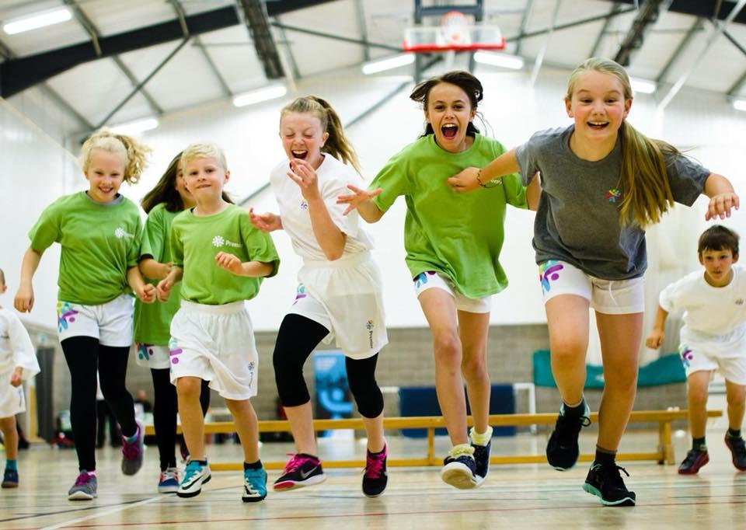 | Sports Day Preparation  Theme: run,  Jump, throw.  Coverage: development of fundamental movement skills  for run, throw, jump | Sports Day Athletics  Theme:Different ways of running, jumping and throwing.  Coverage: Developing fundamental sports skills (FSS) for athletics  events. To include  competition vs. self. | Sports Day Athletics  Theme: Running, jumping and throwing skills, setting personal targets  Coverage: Developing fundamental sports skills (FSS) for athletics  events. To include  competition vs. others | Athletics  Theme: Running, jumping and  throwing skills, partner work.  Coverage: Developing hurdle and running events with a partner. Competing in pairs in  throwing and jumping events. | Athletics  Theme: Running/ jumping/throwing. Time and direction.  Coverage: Competing against others, develop numeracy cross curricular links to focus on timing and direction to maximise performance in  running, jumping and  throwing events | Athletics  Theme: Running, jumping and throwing. Personal best.  Coverage: Practice a variety of athletics  events from prior learning, developing event specific  techniques for pupils to be able to achieve their personal best. Competition to be  Included. | Athletics  Theme: Running, jumping and throwing. Achieving personal best. Team events.  Coverage: Compete in a variety of athletics events for pupils to  be able to achieve their  personal best. Introduce competitive team events.
Striking and Fielding  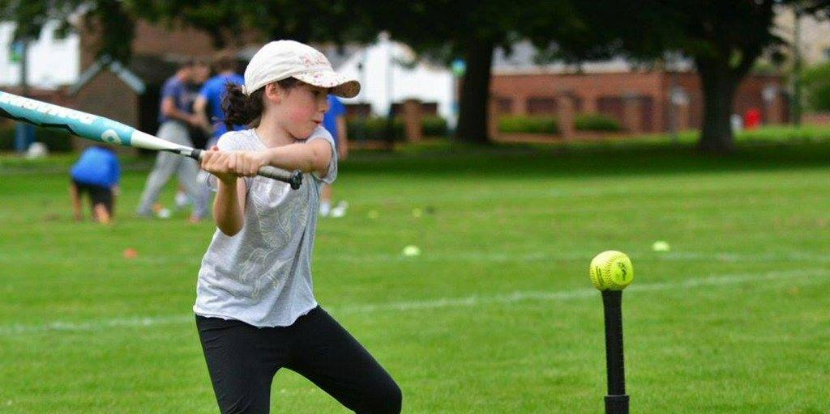 | Team Games  Theme: co-operating, sharing, listening, taking turns  Coverage: A variety of  fundamental movement skills introduced through team activities. | Games  Theme: Striking / fielding related activities (linking skills from previous terms).  Coverage: Developing fundamental sports skills (FSS) for striking  / fielding events. To include competition vs. self. | Games (Striking & Fielding)  Theme: Striking / fielding related  activities (linking skills from previous terms).  Coverage: Developing fundamental sports skills (FSS) for cricket  and playing simplified  versions of the game | Striking & Fielding Games  Theme: Finding and closing down  space.  Coverage: Create small-sided and  modified games of cricket and rounders. Introduce basic rules of these sports | Striking & Fielding Games - Rounder’s  Theme: Bowling & Striking  Coverage: Introduce basic rules of rounders and play competitive modified versions of this game. Introduce sport specific techniques for bowling and striking. | Striking & Fielding Games – Cricket  Theme: Batting and fielding tactics  and strategies  Coverage: Develop rules of cricket and  play competitive modified versions of this game. Introduce sport specific techniques and tactics for fielding and batting. | Striking & Fielding – Cricket & Rounder’s  Theme: Teamwork and tactics  Coverage: Pupils to organise and  compete in full cricket and rounder’s games as well as developing skills as captains, coaches and officiators.

Curriculum Overview
Below is an overview of the curriculum delivery topics that will be delivered throughout the year. We aim to create a broad and balanced PE curriculum that also revisits the skills developed at different touch points throughout the year to reinforce the learning within that topic. The curriculum will also be developed to link into other key values and topics within the school.

 | Autumn 1 | Autumn 2 | Spring 1 | Spring 2 | Summer 1 | Summer 2
EYFS | Fundamental movement skills | Ball/multi skills | Movement to music | Gymnastics | Ball/Multi Skills | Fundamental movements skills
Year 1 | Invasion Games  Gymnastics | Striking and fielding  Dance | Multi-skills  Goal | Invasion Games  Net/wall activities | Striking and fielding  (1 session) | Athletics and sports day activities
Year 2 | Invasion Games  Gymnastics | Striking and fielding  Dance | Multi-skills  Goal | Invasion Games  Net/wall activities | Striking and fielding  (1 session) | Athletics and sports day activities
Year 3 | Invasion Games  Gymnastics | Striking and fielding  Dance | Invasion Games  Goal | Invasion Games  Net/wall activities | Striking and fielding  (1 session) | Athletics and sports day activities
Year 4 | Invasion Games  Gymnastics | Striking and fielding  Dance | Invasion Games  Goal | Invasion Games  Net/wall activities | Striking and fielding  (1 session) | Athletics and sports day activities
Year 5 | Invasion Games  Gymnastics | Striking and fielding  Dance | Invasion Games  Goal | Invasion Games  Net/wall activities | Striking and fielding  (1 session) | Athletics and sports day activities
Year 6 | Invasion Games  Gymnastics | Striking and fielding  Dance | Invasion Games  Goal | Invasion Games  Net/wall activities | Striking and fielding  (1 session) | Athletics and sports day activities

School PE Curriculum
See the below for an overview of the progression of skills, experiences and developments within each topic. We have also included the year groups termly topic/theme which can be used for a possible line of enquiry for cross curricular links.

Early Years Foundation stage overview
We recognise that PE and sport can positively impact the EYFS prime and specific area of learning and development. Whilst EYFS do not have to do PE, we value the role PE can play within their development and have implemented the below overview to achieved specific early learning goals:

Autumn 1 | Autumn 2 | Spring 1 | Spring 2 | Summer 1 | Summer 2
Multi Skills-  “Time Travel” | Multi Skills –  “Land of Fairy-tale” | Multi Skills –  “Jungle Adventure” | Multi Skills-  “Space Explorers” | Multi Skills –  “Sporty Superheroes” | Multi Skills –  “Beach Trip & the Big Blue Sea”

The above topics will help support/achieve the below early learning goals:

Physical development: Moving and handling: Early Learning Goal Children show good control and coordination in large and small movements. They move confidently in a range of ways, safely negotiating space. They handle equipment and tools effectively, including pencils for writing.

Physical Development: Health and Self-Care: Early Learning Goal Children know the importance for good health of physical exercise, and a healthy diet, and talk about ways to keep healthy and safe. They manage their own basic hygiene and personal needs successfully, including dressing and going to the toilet independently.

Personal, Social and emotional development: Self- Confidence and self-awareness: Early Learning Goal Children are confident to try new activities and say why they like some activities more than others. They are confident to speak in a familiar group, will talk about their ideas, and will choose the resources they need for their chosen activities. They say when they do or don’t need help.

Expressive arts and design: being imaginative Early Learning Goal Children use what they have learnt about media and materials in original ways, thinking about uses and purposes. They represent their own ideas, thoughts and feelings through design and technology, art, music, dance, role play and stories.

Key Stage 1 overview

Year 1 | Autumn Term |  | Spring Term |  | Summer Term
 | Term 1  : | Term 2 | Term 1 | Term 2 | Term 1 | Term 2
 | Multi Skills  Activity Theme: Fundamental movement (ABC) and ball skills to develop a basic understand of control with the body and simple pieces of equipment Sports – Basketball, Football, Netball, Hockey, Rugby  - Skills: Skills of travel, send, chase, receive, avoid, dodge, control; awareness of space and partner  - Experience: Experience a variety of games equipment; practicing with a partner; competition, simple rules  - Develop: Develop simple games (net/wall, striking, goal scoring), playing these games – alone/with a partner | Gymnastics  Activity Theme: Physical exercise designed to develop and display strength, balance and agility through using own body weight style exercises. Equipment and apparatus can be used to challenge children with creativity, flexibility, technique, control and balance.  - Skills: Skills of travelling, stillness, balance, turning, rolling, climbing, swinging, weight on hands, placing apparatus, jumping – (with more control, combinations, contrast, complex, actions – requiring continuity and co-ordination of body parts).  - Experience: Experience using floor and apparatus, safe lifting and carrying, using/finding space, using different body parts -shape/levels/direction, improving actions, making up a sequence.  - Develop: Develop working together, body control, planning/practicing simple actions alone using correct language for actions/apparatus | Movement To Music  Activity Theme: Physical exercise designed to challenge the children’s creativity and imagination. Designed for children to develop the ability to move rhythmically to music either creating or following a sequence of steps or movement patterns.  - Skills: Skills of travelling, jumping,  - turning, stillness, balance; changing shape, size, level, speed, tension  - Experience: Experience exploring moods and feelings, responding spontaneously; a range/variety of stimuli, performing movements/patterns some from different times and cultures  Develop: Develop making dances with clear beginning/middle/end; responding to rhythm, music, coordination and control | Invasion Games  Activity Theme: Team based games / sports with an emphasis on working within a set area using a variety of skills such as attacking & defending, Maintaining possession, winning back possession and tactical knowledge. Key Sports – Basketball, Football, Netball, Hockey, Rugby  - Skills: Skills of travel, send, chase, receive, avoid, dodge, control; awareness of space and partner  - Experience: Experience a variety of games equipment; practicing with a partner; competition, simple rules  - Develop: Develop simple games (net/wall, striking, goal scoring), playing these games – alone/with a partner | Striking and Fielding  Activity Theme: Team based games / sports with an emphasis on hitting an object (ball) into a space to gain an advantage, Points scoring is key as well as tactical knowledge from both attacking & defending teams. Teamwork is vital within this topic to be successful. Key Sports – Rounders, cricket, T-Ball, Softball.  - Skills: Skills of travel, send, chase, receive, avoid, dodge, control; awareness of space and partner  - Experience: Experience a variety of games equipment; practicing with a partner; competition, simple rules  - Develop: Develop simple games (net/wall, striking, goal scoring), playing these games – alone/with a partner | Athletics/sports day activities  Activity Theme: Team and individual style events designed to test the children across a variety of running, jumping and throwing events. Strength, Technique, Control & Balance are key areas within athletics also being able to compare performances and demonstrate improvements to achieve success.  - Skills: Skills of running, throwing, jumping, direction, control, accuracy  - Experience: Experience indoor/outdoor areas, competition and games, variety of activities and equipment which stimulate skill and learning development  - Develop: Develop an understanding of safe practice linked to the activities
 | Movement To Music  Activity Theme: Physical exercise designed to challenge the children’s creativity and imagination. Designed for children to develop the ability to move rhythmically to music either creating or following a sequence of steps or movement patterns.  - Skills: Skills of travelling, jumping,  - turning, stillness, balance; changing shape, size, level, speed, tension  - Experience: Experience exploring moods and feelings, responding spontaneously; a range/variety of stimuli, performing movements/patterns some from different times and cultures  - Develop: Develop making dances with clear beginning/middle/end; responding to rhythm, music, coordination and control | Striking and Fielding  Activity Theme: Team based games / sports with an emphasis on hitting an object (ball) into a space to gain an advantage, Points scoring is key as well as tactical knowledge from both attacking & defending teams. Teamwork is vital within this topic to be successful. Key Sports – Rounders, cricket, T-Ball, Softball.  - Skills: Skills of travel, send, chase, receive, avoid, dodge, control; awareness of space and partner  - Experience: Experience a variety of games equipment; practicing with a partner; competition, simple rules  - Develop: Develop simple games (net/wall, striking, goal scoring), playing these games – alone/with a partner | Multi Skills  Activity Theme: Fundamental movement (ABC) and ball skills to develop a basic understand of control with the body and simple pieces of equipment Sports – Basketball, Football, Netball, Hockey, Rugby  - Skills: Skills of travel, send, chase, receive, avoid, dodge, control; awareness of space and partner  - Experience: Experience a variety of games equipment; practicing with a partner; competition, simple rules  - Develop: Develop simple games (net/wall, striking, goal scoring), playing these games – alone/with a partner | Gymnastics  Activity Theme: Physical exercise designed to develop and display strength, balance and agility through using own body weight style exercises. Equipment and apparatus can be used to challenge children with creativity, flexibility, technique, control and balance.  - Skills: Skills of travelling, stillness, balance, turning, rolling, climbing, swinging, weight on hands, placing apparatus, jumping – (with more control, combinations, contrast, complex, actions – requiring continuity and co-ordination of body parts).  - Experience: Experience using floor and apparatus, safe lifting and carrying, using/finding space, using different body parts -shape/levels/direction, improving actions, making up a sequence.  - Develop: Develop working together, body control, planning/practicing simple actions alone using correct language for actions/apparatus | Invasion Games  Activity Theme: Team based games / sports with an emphasis on working within a set area using a variety of skills such as attacking & defending, Maintaining possession, winning back possession and tactical knowledge. Key Sports – Basketball, Football, Netball, Hockey, Rugby  - Skills: Skills of travel, send, chase, receive, avoid, dodge, control; awareness of space and partner  - Experience: Experience a variety of games equipment; practicing with a partner; competition, simple rules  - Develop: Develop simple games (net/wall, striking, goal scoring), playing these games – alone/with a partner | Athletics/sports day activities  Activity Theme: Team and individual style events designed to test the children across a variety of running, jumping and throwing events. Strength, Technique, Control & Balance are key areas within athletics also being able to compare performances and demonstrate improvements to achieve success.  - Skills: Skills of running, throwing, jumping, direction, control, accuracy  - Experience: Experience indoor/outdoor areas, competition and games, variety of activities and equipment which stimulate skill and learning development  - Develop: Develop an understanding of safe practice linked to the activities

Year 2 | Autumn Term |  | Spring Term |  | Summer Term
 | Term 1 | Term 2 | Term 1 | Term 2 | Term 1 | Term 2
 | Multi skills  Activity Theme: Fundamental movement (ABC) and ball skills to develop a basic understand of control with the body and simple pieces of equipment Sports – Basketball, Football, Netball, Hockey, Rugby  - Skills: Skills of travel, send, chase, receive, avoid, dodge, control; awareness of other players  - Experience: Experience a variety of games equipment; practicing in trios; competition, simple rules and tactics for attacking and defending  - Develop: Develop making up simple games, playing (net/wall, striking, goal scoring), playing these games – alone/pairs/groups | Gymnastics  Activity Theme: Physical exercise designed to develop and display strength, balance and agility through using own body weight style exercises. Equipment and apparatus can be used to challenge children with creativity, flexibility, technique, control and balance.  - Skills: Skills of travelling, stillness, balance, turning, rolling, climbing, swinging, weight on hands, placing apparatus, jumping  - Experience: Experience consolidating work identified in this section from Year One, adapting and improving control of actions  - Develop: Develop and consolidate work identified in this section from Year One with emphasis in repeating sequences of movements, linking activities on floor/apparatus, using pupils’ own choices to link skills and actions in short movement phrases | Movement to Music  Activity Theme: Physical exercise designed to challenge the children’s creativity and imagination. Designed for children to develop the ability to move rhythmically to music either creating or following a sequence of steps or movement patterns.  - Skills: Skills of travelling, jumping, turning, stillness, balance; changing shape, size, level, contrasts of speed, continuity of actions  - Experience: Experience exploring moods and feelings, responding spontaneously; a range/variety of stimuli, performing movements/patterns some from different times and cultures  - Develop: Develop making dances with clear beginning/middle/end; responding imaginatively to rhythm, music, co-ordination, control, rhythmic responses, poise and elevation | Invasion Games  Activity Theme: Team based games / sports with an emphasis on working within a set area using a variety of skills such as attacking & defending, Maintaining possession, winning back possession and tactical knowledge. Key Sports – Basketball, Football, Netball, Hockey, Rugby  - Skills: Skills of travel, send, chase, receive, avoid, dodge, control; awareness of other players  - Experience: Experience a variety of games equipment; practicing in trios; competition, simple rules and tactics for attacking and defending  - Develop: Develop making up simple games, playing (net/wall, striking, goal scoring), playing these games – alone/pairs/groups | Striking and Fielding  Activity Theme: Team based games / sports with an emphasis on hitting an object (ball) into a space to gain an advantage, Points scoring is key as well as tactical knowledge from both attacking & defending teams. Teamwork is vital within this topic to be successful. Key Sports – Rounder’s, Cricket, T-Ball  - Skills: Skills of travel, send, chase, receive, avoid, dodge, control; awareness of other players  - Experience: Experience a variety of games equipment; practicing in trios; competition, simple rules and tactics for attacking and defending  - Develop: Develop making up simple games, playing (net/wall, striking, goal scoring), playing these games – alone/pairs/groups | Athletics/sports day activities  Activity Theme: Team and individual style events designed to test the children across a variety of running, jumping and throwing events. Strength, Technique, Control & Balance are key areas within athletics also being able to compare performances and demonstrate improvements to achieve success.  - Skills: Skills of running, throwing, jumping, direction, control, accuracy and distance  - Experience: Experience indoor/outdoor areas, competition and games, variety of activities and equipment which stimulate skill and learning development  - Develop: Develop an understanding of safe practice linked to the activities
 | Movement to Music  Activity Theme: Physical exercise designed to challenge the children’s creativity and imagination. Designed for children to develop the ability to move rhythmically to music either creating or following a sequence of steps or movement patterns.  - Skills: Skills of travelling, jumping, turning, stillness, balance; changing shape, size, level, contrasts of speed, continuity of actions  - Experience: Experience exploring moods and feelings, responding spontaneously; a range/variety of stimuli, performing movements/patterns some from different times and cultures  - Develop: Develop making dances with clear beginning/middle/end; responding imaginatively to rhythm, music, co-ordination, control, rhythmic responses, poise and elevation | Striking and Fielding  Activity Theme: Team based games / sports with an emphasis on hitting an object (ball) into a space to gain an advantage, Points scoring is key as well as tactical knowledge from both attacking & defending teams. Teamwork is vital within this topic to be successful. Key Sports – Rounder’s, Cricket, T-Ball  - Skills: Skills of travel, send, chase, receive, avoid, dodge, control; awareness of other players  - Experience: Experience a variety of games equipment; practicing in trios; competition, simple rules and tactics for attacking and defending  - Develop: Develop making up simple games, playing (net/wall, striking, goal scoring), playing these games – alone/pairs/groups | Multi skills  Activity Theme: Fundamental movement (ABC) and ball skills to develop a basic understand of control with the body and simple pieces of equipment Sports – Basketball, Football, Netball, Hockey, Rugby  - Skills: Skills of travel, send, chase, receive, avoid, dodge, control; awareness of other players  - Experience: Experience a variety of games equipment; practicing in trios; competition, simple rules and tactics for attacking and defending  - Develop: Develop making up simple games, playing (net/wall, striking, goal scoring), playing these games – alone/pairs/groups | Gymnastics  Activity Theme: Physical exercise designed to develop and display strength, balance and agility through using own body weight style exercises. Equipment and apparatus can be used to challenge children with creativity, flexibility, technique, control and balance.  - Skills: Skills of travelling, stillness, balance, turning, rolling, climbing, swinging, weight on hands, placing apparatus, jumping  - Experience: Experience consolidating work identified in this section from Year One, adapting and improving control of actions  - Develop: Develop and consolidate work identified in this section from Year One with emphasis in repeating sequences of movements, linking activities on floor/apparatus, using pupils’ own choices to link skills and actions in short movement phrases | Invasion Games  Activity Theme: Team based games / sports with an emphasis on working within a set area using a variety of skills such as attacking & defending, Maintaining possession, winning back possession and tactical knowledge. Key Sports – Basketball, Football, Netball, Hockey, Rugby  - Skills: Skills of travel, send, chase, receive, avoid, dodge, control; awareness of other players  - Experience: Experience a variety of games equipment; practicing in trios; competition, simple rules and tactics for attacking and defending  - Develop: Develop making up simple games, playing (net/wall, striking, goal scoring), playing these games – alone/pairs/groups | Athletics/sports day activities  Activity Theme: Team and individual style events designed to test the children across a variety of running, jumping and throwing events. Strength, Technique, Control & Balance are key areas within athletics also being able to compare performances and demonstrate improvements to achieve success.  - Skills: Skills of running, throwing, jumping, direction, control, accuracy and distance  - Experience: Experience indoor/outdoor areas, competition and games, variety of activities and equipment which stimulate skill and learning development  - Develop: Develop an understanding of safe practice linked to the activities

Lower Key Stage 2 overview
Year 3 | Autumn Term |  | Spring Term |  | Summer Term
 | Term 1 | Term 2 | Term 1 | Term 2 | Term 1 | Term 2
 | Invasion Games  Activity Theme: Team based games / sports with an emphasis on working within a set area using a variety of skills such as attacking & defending, Maintaining possession, winning back possession and tactical knowledge. Key Sports – Basketball, Football, Netball, Hockey, Rugby  - Skills: Improve skills of travel, send chase, receive, dodge, avoid, attack, defend, control accuracy; movement into/out of space  - Experience: Experience small sided and simplified versions of different types of games, (i.e. invasion/net & wall/strike & field); a variety of common skills and game principles; team work; working towards tasks set by themselves and the teacher, competition  - Develop: Develop team games, making up games, own game practices, understanding of game principles | Gymnastics  Activity Theme: Physical exercise designed to develop and display strength, balance and agility through using own body weight style exercises. Equipment and apparatus can be used to challenge children with creativity, flexibility, technique, control and balance.  - Skills: Improve skills of rolling, jumping, swinging, balancing, taking weight on hands; changing speed, direction, shape levels; using different combinations of floor and apparatus, working alone/ with partner  - Experience: Experience performing and remembering sequences, with control; responding to set tasks, short sequences, selecting apparatus  - Develop: Develop an understanding of actions ending one movement – starts next; making decisions to effect their actions | Dance  Activity Theme: Physical exercise designed to challenge the children’s creativity and imagination. Designed for children to develop the ability to move rhythmically to music either creating or following a sequence of steps or movement patterns.  - Skills: Improve skills of travelling, jumping, turning, stillness, changing size/shape/level/ direction; increase range of body actions; compose, practice and perform actions with control  - Experience: Experience responding to a range of music/stimuli, expressing moods and feelings  - Develop: Develop making own dances with clear beginnings/middle/end. Understand the different elements of dance; control, co-ordination, poise and elevation. A number of dance forms from different times, cultures and places | Net/wall games activities  Activity Theme: Individual / team based games which involve hitting an object into a court space / set area and your opponents are unable to return. Tactical skills are key as well as attacking & defending, problem solving and hand eye coordination  - Skills: Improve skills of travel, send chase, receive, dodge, avoid, attack, defend, control accuracy; movement into/out of space  - Experience: Experience small sided and simplified versions of different types of games, (i.e. invasion/net & wall/strike & field); a variety of common skills and game principles; team work; working towards tasks set by themselves and the teacher, competition  - Develop: Develop team games, making up games, own game practices, understanding of game principles | Striking and Fielding  Activity Theme: Team based games / sports with an emphasis on hitting an object (ball) into a space to gain an advantage, Points scoring is key as well as tactical knowledge from both attacking & defending teams. Teamwork is vital within this topic to be successful. Key Sports – Rounder’s, Cricket, T-Ball  - Skills: Improve skills of travel, send chase, receive, dodge, avoid, attack, defend, control accuracy; movement into/out of space  - Experience: Experience small sided and simplified versions of different types of games, (i.e. invasion/net & wall/strike & field); a variety of common skills and game principles; team work; working towards tasks set by themselves and the teacher, competition  - Develop: Develop team games, making up games, own game practices, understanding of game principles | Athletics/sports day activities  Activity Theme: Team and individual style events designed to test the children across a variety of running, jumping and throwing events. Strength, Technique, Control & Balance are key areas within athletics also being able to compare performances and demonstrate improvements to achieve success.  - Skills: Improve skills of running, throwing, jumping; refine basic technique by emphasis on accuracy, time, measurement, length, distance  - Experience: Experience outdoor areas, measuring and timing activities, competition, activities and equipment which support refining basic techniques  - Develop: Develop understanding of safe practice linked to activities, comparing and improvement of own performance
 | Dance  Activity Theme: Physical exercise designed to challenge the children’s creativity and imagination. Designed for children to develop the ability to move rhythmically to music either creating or following a sequence of steps or movement patterns.  - Skills: Improve skills of travelling, jumping, turning, stillness, changing size/shape/level/ direction; increase range of body actions; compose, practice and perform actions with control  - Experience: Experience responding to a range of music/stimuli, expressing moods and feelings  - Develop: Develop making own dances with clear beginnings/middle/end. Understand the different elements of dance; control, co-ordination, poise and elevation. A number of dance forms from different times, cultures and places | Striking and Fielding  Activity Theme: Team based games / sports with an emphasis on hitting an object (ball) into a space to gain an advantage, Points scoring is key as well as tactical knowledge from both attacking & defending teams. Teamwork is vital within this topic to be successful. Key Sports – Rounder’s, Cricket, T-Ball  - Skills: Improve skills of travel, send chase, receive, dodge, avoid, attack, defend, control accuracy; movement into/out of space  - Experience: Experience small sided and simplified versions of different types of games, (i.e. invasion/net & wall/strike & field); a variety of common skills and game principles; team work; working towards tasks set by themselves and the teacher, competition  - Develop: Develop team games, making up games, own game practices, understanding of game principles | Invasion Games  Activity Theme: Team based games / sports with an emphasis on working within a set area using a variety of skills such as attacking & defending, Maintaining possession, winning back possession and tactical knowledge. Key Sports – Basketball, Football, Netball, Hockey, Rugby  - Skills: Improve skills of travel, send chase, receive, dodge, avoid, attack, defend, control accuracy; movement into/out of space  - Experience: Experience small sided and simplified versions of different types of games, (i.e. invasion/net & wall/strike & field); a variety of common skills and game principles; team work; working towards tasks set by themselves and the teacher, competition  - Develop: Develop team games, making up games, own game practices, understanding of game principles | Gymnastics  Activity Theme: Physical exercise designed to develop and display strength, balance and agility through using own body weight style exercises. Equipment and apparatus can be used to challenge children with creativity, flexibility, technique, control and balance.  - Skills: Improve skills of rolling, jumping, swinging, balancing, taking weight on hands; changing speed, direction, shape levels; using different combinations of floor and apparatus, working alone/ with partner  - Experience: Experience performing and remembering sequences, with control; responding to set tasks, short sequences, selecting apparatus  - Develop: Develop an understanding of actions ending one movement – starts next; making decisions to effect their actions | Net/wall games activities  Activity Theme: Individual / team based games which involve hitting an object into a court space / set area and your opponents are unable to return. Tactical skills are key as well as attacking & defending, problem solving and hand eye coordination  - Skills: Improve skills of travel, send chase, receive, dodge, avoid, attack, defend, control accuracy; movement into/out of space  - Experience: Experience small sided and simplified versions of different types of games, (i.e. invasion/net & wall/strike & field); a variety of common skills and game principles; team work; working towards tasks set by themselves and the teacher, competition  - Develop: Develop team games, making up games, own game practices, understanding of game principles | Athletics/sports day activities  Activity Theme: Team and individual style events designed to test the children across a variety of running, jumping and throwing events. Strength, Technique, Control & Balance are key areas within athletics also being able to compare performances and demonstrate improvements to achieve success.  - Skills: Improve skills of running, throwing, jumping; refine basic technique by emphasis on accuracy, time, measurement, length, distance  - Experience: Experience outdoor areas, measuring and timing activities, competition, activities and equipment which support refining basic techniques  - Develop: Develop understanding of safe practice linked to activities, comparing and improvement of own performance

Year 4 | Autumn Term |  | Spring Term |  | Summer Term
 | Term 1 | Term 2 | Term 1 | Term 2 | Term 1 | Term 2
 | Invasion Games  Activity Theme: Team based games / sports with an emphasis on working within a set area using a variety of skills such as attacking & defending, Maintaining possession, winning back possession and tactical knowledge. Key Sports – Basketball, Football, Netball, Hockey, Rugby  - Skills: Improve skills of travel, send chase, receive, dodge, avoid, attack, defend, control accuracy; movement into/out of space  - Experience: Experience small sided and simplified versions of different types of games, (i.e. invasion/net & wall/strike & field); a variety of common skills and game principles; team work; working towards tasks set by themselves and the teacher, competition  - Develop: Develop team games, making up games, own game practices, understanding of game principles | Gymnastics  Activity Theme: Physical exercise designed to develop and display strength, balance and agility through using own body weight style exercises. Equipment and apparatus can be used to challenge children with creativity, flexibility, technique, control and balance.  - Skills: Improve skills of rolling, jumping, swinging, balancing, taking weight on hands; changing speed, direction, shape levels; using different combinations of floor and apparatus, working alone/ with partner. Practice, adapt and refine actions; perform with whole/part body control; explore and select actions which can be developed within sequences, practiced and repeated through gymnastic actions  - Experience: Experience sequences which they remember and repeat, respond to a variety of tasks, longer sequences, apparatus choice  - Develop: Develop an understanding of selecting more relevant actions, continuity when linking movement actions | Dance  Activity Theme: Physical exercise designed to challenge the children’s creativity and imagination. Designed for children to develop the ability to move rhythmically to music either creating or following a sequence of steps or movement patterns  - Skills: Improve skills of travelling, jumping, turning, stillness, changing size/shape/level/direction; using whole body control; explore and select actions which can be developed within chances, practiced and repeated  - Experience: Experience responding to a range of music/stimuli, expressing moods and feelings  - Develop: Develop selecting content for making dances; discussing the different elements of dance; control, co-ordination, poise and elevation. A number of dance forms from different times, cultures and places | Net/Wall game activities  Activity Theme: Individual / team based games which involve hitting an object into a court space / set area and your opponents are unable to return. Tactical skills are key as well as attacking & defending, problem solving and hand eye coordination  - Skills: Improve skills of travel, send chase, receive, dodge, avoid, attack, defend, control accuracy; movement into/out of space  - Experience: Experience small sided and simplified versions of different types of games, (i.e. invasion/net & wall/strike & field); a variety of common skills and game principles; team work; working towards tasks set by themselves and the teacher, competition  - Develop: Develop team games, making up games, own game practices, understanding of game principles | Striking and Fielding  Activity Theme: Team based games / sports with an emphasis on hitting an object (ball) into a space to gain an advantage, Points scoring is key as well as tactical knowledge from both attacking & defending teams. Teamwork is vital within this topic to be successful. Key Sports – Rounder’s, Cricket, T-Ball  - Skills: Improve skills of travel, send chase, receive, dodge, avoid, attack, defend, control accuracy; movement into/out of space  - Experience: Experience small sided and simplified versions of different types of games, (i.e. invasion/net & wall/strike & field); a variety of common skills and game principles; team work; working towards tasks set by themselves and the teacher, competition  - Develop: Develop team games, making up games, own game practices, understanding of game principles | Athletics/sports day activities  Activity Theme: Team and individual style events designed to test the children across a variety of running, jumping and throwing events. Strength, Technique, Control & Balance are key areas within athletics also being able to compare performances and demonstrate improvements to achieve success.  - Skills: Improve skills of running, throwing, jumping, refine basic technique by emphasis on accuracy, time, measurement, length, distance  - Experience: Experience outdoor areas, measuring and timing activities, competition, activities and equipment which support refining basic techniques  - Develop: Develop understanding of safe practice linked to activities, comparing and improvement of own performance
 | Dance  Activity Theme: Physical exercise designed to challenge the children’s creativity and imagination. Designed for children to develop the ability to move rhythmically to music either creating or following a sequence of steps or movement patterns  - Skills: Improve skills of travelling, jumping, turning, stillness, changing size/shape/level/direction; using whole body control; explore and select actions which can be developed within chances, practiced and repeated  - Experience: Experience responding to a range of music/stimuli, expressing moods and feelings  - Develop: Develop selecting content for making dances; discussing the different elements of dance; control, co-ordination, poise and elevation. A number of dance forms from different times, cultures and places | Striking and Fielding  Activity Theme: Team based games / sports with an emphasis on hitting an object (ball) into a space to gain an advantage, Points scoring is key as well as tactical knowledge from both attacking & defending teams. Teamwork is vital within this topic to be successful. Key Sports – Rounder’s, Cricket, T-Ball  - Skills: Improve skills of travel, send chase, receive, dodge, avoid, attack, defend, control accuracy; movement into/out of space  - Experience: Experience small sided and simplified versions of different types of games, (i.e. invasion/net & wall/strike & field); a variety of common skills and game principles; team work; working towards tasks set by themselves and the teacher, competition  - Develop: Develop team games, making up games, own game practices, understanding of game principles | Invasion Games  Activity Theme: Team based games / sports with an emphasis on working within a set area using a variety of skills such as attacking & defending, Maintaining possession, winning back possession and tactical knowledge. Key Sports – Basketball, Football, Netball, Hockey, Rugby  - Skills: Improve skills of travel, send chase, receive, dodge, avoid, attack, defend, control accuracy; movement into/out of space  - Experience: Experience small sided and simplified versions of different types of games, (i.e. invasion/net & wall/strike & field); a variety of common skills and game principles; team work; working towards tasks set by themselves and the teacher, competition  - Develop: Develop team games, making up games, own game practices, understanding of game principles | Gymnastics  Activity Theme: Physical exercise designed to develop and display strength, balance and agility through using own body weight style exercises. Equipment and apparatus can be used to challenge children with creativity, flexibility, technique, control and balance.  - Skills: Improve skills of rolling, jumping, swinging, balancing, taking weight on hands; changing speed, direction, shape levels; using different combinations of floor and apparatus, working alone/ with partner. Practice, adapt and refine actions; perform with whole/part body control; explore and select actions which can be developed within sequences, practiced and repeated through gymnastic actions  - Experience: Experience sequences which they remember and repeat, respond to a variety of tasks, longer sequences, apparatus choice  - Develop: Develop an understanding of selecting more relevant actions, continuity when linking movement actions | Net/Wall game activities  Activity Theme: Individual / team based games which involve hitting an object into a court space / set area and your opponents are unable to return. Tactical skills are key as well as attacking & defending, problem solving and hand eye coordination  - Skills: Improve skills of travel, send chase, receive, dodge, avoid, attack, defend, control accuracy; movement into/out of space  - Experience: Experience small sided and simplified versions of different types of games, (i.e. invasion/net & wall/strike & field); a variety of common skills and game principles; team work; working towards tasks set by themselves and the teacher, competition | Athletics/sports day activities  Activity Theme: Team and individual style events designed to test the children across a variety of running, jumping and throwing events. Strength, Technique, Control & Balance are key areas within athletics also being able to compare performances and demonstrate improvements to achieve success.  - Skills: Improve skills of running, throwing, jumping, refine basic technique by emphasis on accuracy, time, measurement, length, distance  - Experience: Experience outdoor areas, measuring and timing activities, competition, activities and equipment which support refining basic techniques  - Develop: Develop understanding of safe practice linked to activities, comparing and improvement of own performance

