Reedham Primary and Nursery School
By working together, we learn, we achieve, we care

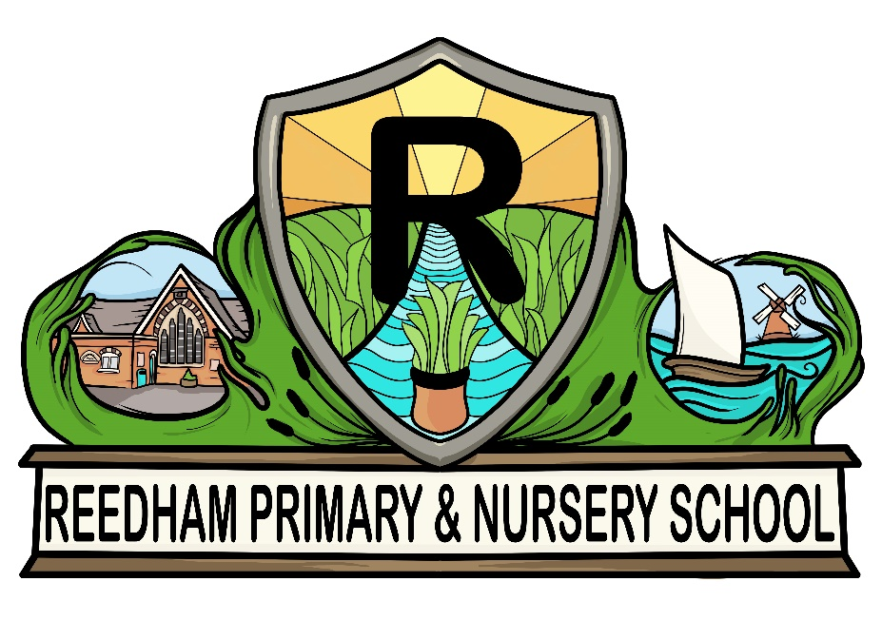

School Prospectus

Website: www.reedham.norfolk.sch.uk
Twitter: @ReedhamPrimary
Telephone: 01493 700271

Interim Headteacher: Miss B Spaul
Chair of Governors: Mrs De Jarvis
Contents
Aims of the School
Welcome by the Headteacher…………………………………………………………………….
Welcome by the Chair of Governors…………………………………………………………….
Staff and Governing Body…………………………………………………………………………..
The School Year 2023/2024………………………………………………………………………..
The School Day………………………………………………………………………………………….
Assembly…………………………………………………………………………………………………..
Absences from School / Term Time Holidays…………………………………………………
Before and After School Clubs……………………………………………………………………..
Uniform and Lost Property…………………………………………………………………………..
Help In School and PFA……………………………………………………………………………….
Behaviour and School Rules…………………………………………………………………………
Safeguarding Children…………………………………………………………………………………
School Council……………………………………………………………………………………………
School Curriculum………………………………………………………………………………………
SEN and Communications…………………………………………………………………………...
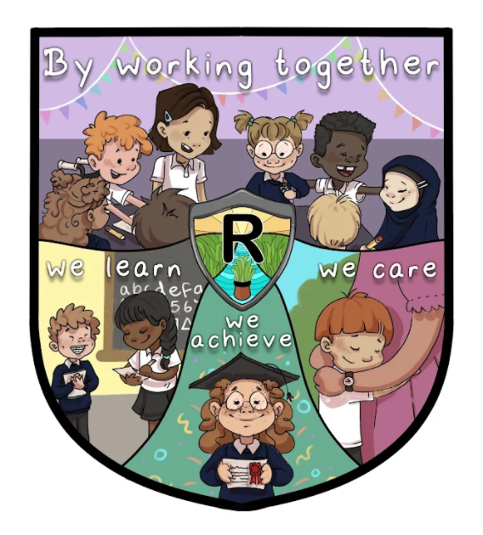
Admissions Policy……………………………………………………………………………………….
Aims of the School

Our school mission statement is:
"By working together, we learn, we achieve, we care"

At Reedham Primary School, through a positive community ethos we listen, engage and nurture a can-do attitude in order to prepare all learners for their future lives, enabling and enjoying learning within the context of a rapidly changing technological society.

We aim:
- To create a rich, stimulating and caring school environment in which every child feels happy, safe secure and confident.
- To provide high quality teaching and learning experiences to enable all children to achieve the highest possible standards in all areas of the curriculum.
- To provide a curriculum that is broad, balanced, relevant and differentiated to meet the needs of all children, including those with special needs.
- To encourage a love of learning and high expectations of standards of achievement and behaviour.
- To develop strong values of tolerance, self-respect, respect of others, responsibility and politeness in all our children.
- To praise, encourage and celebrate success.
- To foster good relationships between the home and school, welcoming parents into the school and encourage them to work in partnership and harmony with the staff.
- To ‘bring out the best’ in every child so they can all be the best they can be. Together, we endeavour to develop the following skills:
  - Independent Enquiry
  - Creative Thinking
  - Reflective Learning
  - Teamwork
  - Responsibility

By developing these five skills, we aim to promote motivation, resilience, and aspiration in all children, enabling them to effectively participate and engage with learning.

Welcome by the Headteacher

Dear Parents/Carers

We are delighted to welcome you to Reedham Primary and Nursery School.

Our school is located in the village of Reedham and the original buildings date back to 1871. Over the years the school has expanded and been modified. As of June 2023 we have 69 pupils on roll, aged 4-11.

The school is arranged in three mixed aged classes. Each class is taught by a
qualified teacher who is supported by a teaching assistant. Our Foundation Stage class has the benefit of a large room, a back room and a good outside play area. Each classroom is equipped with computers for pupil use, in addition to smart boards to aid teaching and learning. The grounds have been developed in recent years, with a new asphalt playground, with markings; a trim trail, a tyre play area and nature area. We also have an off-site school field. We are fortunate to have one of the only heated swimming pools on site and all pupils have swimming lessons here during the summer term.

Our school aims to provide a child centred, broad and balanced curriculum, employing the most effective methods of teaching and focussing on developing children’s learning in all areas. The school has close links to our local church and as such Christian values underpin all we do. We aim to give our pupils as many opportunities for learning as possible and offer an increasingly wide range of after school clubs and lunchtime activities.

We build confident, enthusiastic learners in a nurturing and safe environment. Our tolerant, polite, and responsible children take pride in everything they do. They are taught good manners and respect for each other and are exceedingly well prepared for the next stage of their education.

Pupils are encouraged to become independent learners, who are able to think for themselves and treat all around them with respect. We are proud of our achievements and continually seek to improve.

I look forward to sharing in the learning journey of all your children.

Beth Spaul

Interim Headteacher

Welcome by the Chair of Governors

On behalf of the Governing Body, of Reedham Primary and Nursery School, I welcome both you and your child to our school.

Starting school is a milestone in your child’s life. We hope that this brochure will help by providing information about both the curriculum and the running of the school.

The Governors intend to assist in providing the right conditions for the full development of your child’s education.

The Staff’s efforts will be focused on ensuring that all children receive the best possible education and also spend a happy and fulfilling time at Reedham. With this in mind, extra-curricular activities will be included with the intention that children will gain social skills, be able to judge issues on moral grounds and also value the spiritual side of life.

A supportive partnership between school and home is important if your child is to do well. We therefore encourage you to keep in regular touch with the school.

Should you have further questions please feel free to contact the school office or any of the governors.

De Jarvis
Chair of Governors

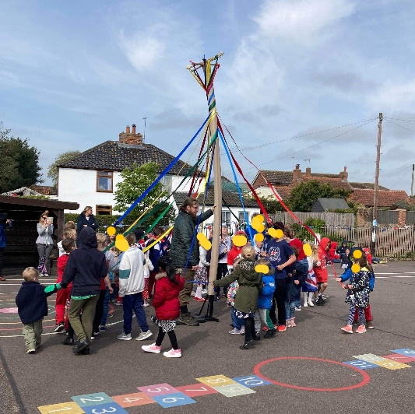
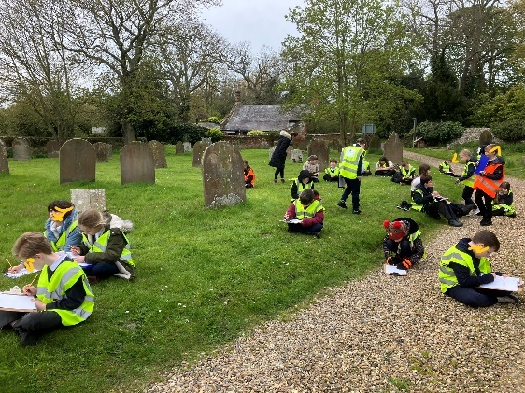

Staff Governing Body

Headteacher: Miss Beth Spaul Chair of Governors: Mrs De Jarvis
Vice-Chair: Mrs Hayley Smith
Teaching Staff: Parent Representatives:
Mr Mathew Hunt Mrs Serena Bastillo
Miss Sophie Waters Miss Sam Osborn
Mrs Sam Bethell Co-opted Governors:
Mrs Mary Jones
Ms Isla McFadden
Teaching Assistants: Dr Anupama De Silva
Mrs Louise Woodards Staff Governor:
Miss Charlotte Boxall Mrs Donna Kelf
Mrs Donna Kelf Clerk to the Governors:
Miss Fran Baker

Nursery Staff:
Early Years Lead Practitioner:
Mrs Ruth Shepherd
Early Years Practitioners:
Miss Juliet Ebbage
Mrs Yellowisha Pluckrose
Mrs Josie Smyth

Support Staff:
School Finance Officer and Secretary: Mrs Kirstin Saunders
School Secretary: Miss Fran Baker
Caretaker: Mr A McPherson
Midday Supervisory Assistant: Mrs Tina Free

Premier Sports Coach
Miss Ellie Hunter

Norse Catering
Miss Nicola Lamacraft
The School Year 2023/24

Autumn Term 2023
Tuesday 6th September Autumn term commences
Friday 21st October School closes for half-term
Monday 31st October School re-opens
Friday 16th December School closes for Christmas

Spring Term 2024
Wednesday 4th January Spring term commences
Friday 16th February School closes for half-term
Monday 26th February School re-opens
Wednesday 27th March School closes for Easter holiday

Summer Term 2024
Monday 15th April Summer term commences
Monday 6th May May Day Bank Holiday
Friday 24th May School closes for half-term
Monday 3rd June School re-opens
Friday 19th July School closes for Summer holiday

Staff Development Days
These are days when the School is closed to children. For convenience we endeavour to plan them just before or after a school holiday and to tie in with Acle Academy and the rest of our cluster of schools. The following dates have been identified as Staff Development Days:
4th and 5th September 2023, 3rd January 2024, 28th March 2024 and 22nd July 2024.

The School Day

Doors open 08.45am – 08.50am
Registration 08.50am – 09:00am
Early morning session 09:00am – 10.30am
Morning break 10:30am – 10:45am
Late morning session 10:45am – 12.00pm
Assembly 12.00pm – 12.15pm
Lunch break 12.15pm – 13.15pm
Afternoon session 13.15pm – 15.20pm

After 8.50am all entrances to the school building are locked for security reasons and you and your children will need to report to the school office inside the main visitor entrance to be signed in – Thank you.

Assembly
There is a short act of collective assembly each day. This explores core values, which are in line with the school’s vision and ethos. They develop our moral, social and cultural conscience and is a very important element to our PSHE curriculum. Many aspects of the curriculum are also covered during assembly time from science and the planet through to different cultures and their beliefs and special events to explore fundraising and awareness raising. We also love singing in our assemblies!

Absences from School
If your child is absent from school, you must phone us on the first day of absence, preferably before 8:45am. There is an answer machine available to leave a message outside office hours. If we haven’t received a message as to why your child is absent by 9:30am, we will phone you to find out why they are absent. The school can only authorise an absence for certain limited reasons (e.g. ill health). Any unexplained absence has to be recorded as ‘unauthorised’. If absences become too high, the County Attendance Team may become involved in helping you to improve attendance.

Holidays in term time
Requests for family holidays during term time, cannot be authorised by the school. Therefore, their absence will be unauthorised, unless there are exceptional circumstances. These may include:
- Armed forces personnel returning from a tour of duty
- Police or other service personnel whose leave has been cancelled in school holidays
- Family wedding / funeral
Unauthorised absences may be subject to a fixed penalty notice from Norfolk County Council if your child is absent for 10 consecutive sessions (5 days) or has a high percentage of unauthorised absence in any 6 week period.

Before and After School Clubs
The school is delighted to be able to offer wraparound care, every weekday, during term time.

Breakfast Club is run by Mrs Kelf and is available from 8.00am until 8.50 am at the cost of £3.00 per session per child.

After School care is run by Mrs Free or Mrs Pluckrose and is available from 3.20pm to 5.00pm at the cost of £5.00 per session, per child.
ALL CLUBS SHOULD BE BOOKED VIA THE OFFICE PLEASE.

Alongside our wraparound care, there are a variety of sporting clubs throughout the year, managed by Premier Education. For example, this year we have run clubs for football, multi-skills, handball, fencing, tennis and archery clubs. These clubs are available to all children and run throughout the week. There is a charge per session per club. Booking is available through Premier Education’s website and information regarding which clubs are running will be emailed to parents every half term.

The school also hold Booster Classes for SATS in Key Stage 2, which take place during the spring term and is run by members of staff.

School Uniform
All children are expected to wear a school uniform. This helps to both create a
feeling of ‘belonging’ and to develop a working atmosphere.

Uniform | Plain black trousers, shorts or skirts  Plain white polo shirt  Navy jumper or cardigan
PE Kit | Plain white or team coloured t-shirt  Plain black shorts or tracksuit bottoms (no leggings please)  Plain navy hoodie  Appropriate sports shoes (not too brightly coloured please)

Embroidered school uniform is available for purchase online from myclothing.com (please speak to the office about support for this).
- Sweatshirts and cardigans
- Fleeces
- Polo Shirts
- PE bags
- Book bags
ALL items of uniform should be named to avoid loss.

Lost property
Neither the school nor Norfolk County Council can accept responsibility for lost property. Please remember to label all belongings. This will enable us to return missing items to their owners quickly. Any items without names will be left in the outdoor classroom on the playground.

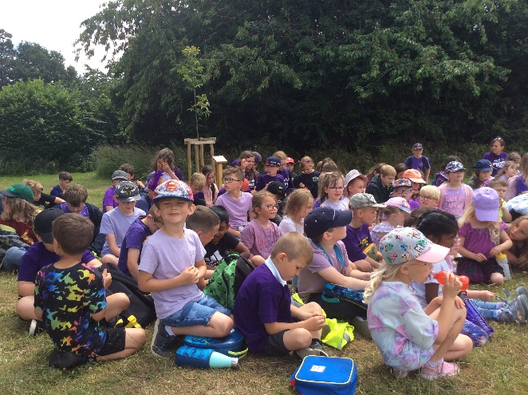

Help in School
Parents are more than welcome to help with the children’s activities and organised trips. Do not hesitate to say if you are interested in helping or have skills to offer in this direction. Help can mean a range of things for a school like ours. Simply sitting next to a child and hearing them read shows that can make a huge difference to the children’s reading ability. It could be backing work for a display or helping to supervise a lunch sitting. You might even be able to talk in depth about a topic we are learning about. We are very flexible and would try to accommodate what you can offer us – after all, it is your time you are giving up for free.

If you are interested and think that you might be able to help speak to myself or Mrs Saunders in the office. The only thing we would ask of you before starting is that you fill out a disclosure form to ensure you are safe to work with children. This form can be completed with Mrs Saunders and is free from cost because you are offering voluntary help. Miss Spaul would then explain the school’s safeguarding and confidentiality arrangements leaving you to make a real difference to the lives of our children.

Parents and Friends of Reedham School
We have a friendly, active and dedicated parents and friends group. Meetings are held throughout the year to organise events for the children or fundraising initiatives. New members are very welcome (and positively encouraged) to attend.
Our PFA has raised a staggering amount of money which has gone to improving the school for the benefit of the children. We hope to continue working together on existing projects and new ideas and are incredibly grateful for all the support that we have received from them.

Behaviour and School Rules
We pride ourselves on the exceptional behaviour at Reedham Primary School as highlighted in our last Ofsted report. Positive recognition is used to motivate pupils to choose responsible behaviour. Rewards are consistently applied and not taken away as a sanction. We use an online behavioural reward system, called ‘Class Dojo’, to track pupil behaviour during a lesson and over a series of lessons. ‘Dojo’ points can be gained and count towards the school’s colour team points competition. When dealing with behaviour, consistency of approach is key. All members of staff are involved with reinforcing the school rules and children are taught to respect themselves, each other and every adult in school.
Where children have completed an exceptional piece of work or gone above and beyond with caring for somebody in our community, they will be sent to the headteacher to share in their positive efforts. This allows the Headteacher an opportunity to reinforce and praise the excellent work and behaviour the child has demonstrated.
We celebrate all of our successes both individually and as a school team in Superstar Assembly. This is another opportunity to praise good behaviour and hard work across the school day in front of the whole school. If you wish to know more about details of the school policy we are more than happy to provide you with a copy.

School Rules
- We keep hands, feet and unwanted comments to ourselves
- We walk around school calmly, safely and sensibly
- We look after each other, our school and the environment
- We listen carefully and do as we are asked first time, every time
- We always try our best in everything we do
- We respect ourselves and each other

Safeguarding Children
The school has a Safeguarding Policy in place.
The policy is to ensure every child at our school is safe and protected from harm. The policy gives clear directions to staff, volunteers, visitors and parents about expected behaviour and our legal responsibility to safeguard and promote the welfare of all children at our school.

Miss Spaul and Mrs Bethell are our Designated Professionals for Safeguarding, with Mrs Ruth Shepherd named as Safeguarding Lead in Early Years. Every member of staff will undertake appropriate safeguarding training annually. The policy is available on our school website. If you wish to see a paper copy this is available from the school office.

School Council
The council get together regularly and hold a structured meeting with their Chair, Vice Chair, Secretary and Treasurer. The children talk about how to improve the school and organise school activities. They fund raise, organise competitions and run a Stationery Shop as a small business concern.
Their latest project has been related to school playtimes; they have been organising competitive team games which count towards their colour team points.

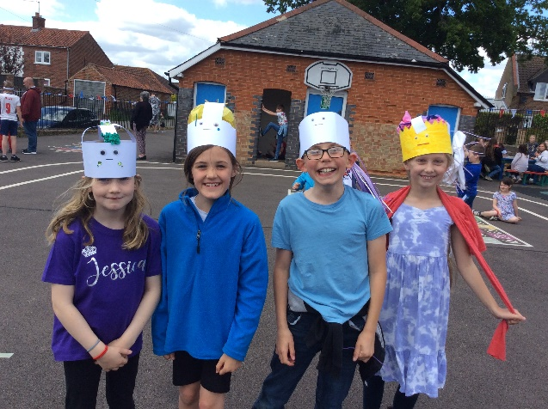

Reedham Primary School Curriculum
As a maintained state school we must follow the Department for Education’s National Curriculum Programmes of Study. In light of this the school provides a balanced curriculum relevant to the individual needs of each child, using the White Rose mastery approach.

Numeracy
Mathematics at Reedham Primary School aims to ensure that all pupils:

- become fluent in the fundamentals of mathematics, including through varied and frequent practice with increasingly complex problems over time, so that pupils have conceptual understanding and are able to recall and apply their knowledge rapidly and accurately to problems
- reason mathematically by following a line of enquiry, conjecturing relationships and generalisations, and developing an argument, justification or proof using mathematical language
- can solve problems by applying their mathematics to a variety of routine and non-routine problems with increasing sophistication, including breaking down problems into a series of simpler steps and persevering in seeking solutions.

Achieving these aims means requires children to have a greater level of numeracy today than ever before. It is our aim to provide a secure foundation for the development of these skills as well as to challenge and develop a love of number and shape.
Numeracy also demands practical understanding of the ways in which information is gathered by counting and measuring, and is presented in graphs, diagrams, charts and tables.
We not only provide a strong academic framework but also ensure the subject is relevant and practical.
All children work to their own ability and progress at a pace that is challenging but realistic.
If you wish to find out more about Mathematics in school, speak to Miss Spaul, the numeracy subject leader.

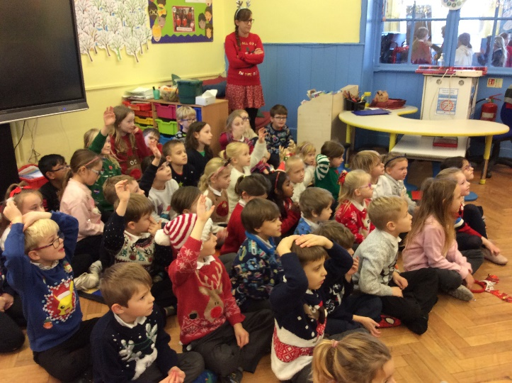
Literacy
At Reedham Primary School the overarching aim for English is to promote high standards of literacy by equipping pupils with a strong command of the written and spoken word. We also want to develop children’s love of literature through widespread reading for enjoyment. We want to skill all pupils to be able to:

- read easily, fluently and with good understanding
- develop the habit of reading widely and often, for both pleasure and information
- acquire a wide vocabulary, an understanding of grammar and knowledge conventions for reading, writing and spoken language
- appreciate our rich and varied literary heritage
- write clearly, accurately and coherently, adapting their language and style in and for a range of contexts, purposes and audiences
- use discussion in order to learn; they should be able to elaborate and explain clearly their understanding and ideas
- be competent in speaking and listening, making formal presentations, demonstrating to others and participating in debate.

To achieve these aims we have daily focused literacy lessons which teach the basic skills. These skills are then used across the whole curriculum.

We emphasise the importance of reading, a skill that is used in all areas. Please encourage your child to read as much as possible at home.
If you wish to find out more about literacy in school, speak to Mrs Bethell, the subject leader.

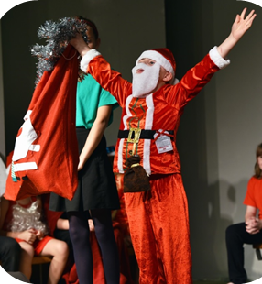

Science
Our science curriculum aims to ensure that all pupils:
- develop scientific knowledge and conceptual understanding
- develop understanding of the nature, processes and methods of science through different types of science enquiries that help them to answer scientific questions about the world around them
- are equipped with the scientific knowledge required to understand the uses and implications of science, today and for the future.

Scientific skills, concepts and knowledge are taught in a variety of ways. Practical investigation is the keystone to the children’s learning and we teach this through the encouragement of questioning and fair testing of ideas. We encourage visits and use external expertise to develop science to the full. If you wish to find out more about literacy in school, speak to Miss Waters, the subject leader.

Design and Technology
The design and technology in school aims to ensure that all pupils:

- develop the creative, technical and practical expertise needed to perform everyday tasks confidently and to participate successfully in an increasingly technological world
- build and apply a repertoire of knowledge, understanding and skills in order to design and make high-quality prototypes and products for a wide range of users
- critique, evaluate and test their ideas and products and the work of others
- understand and apply the principles of nutrition and learn how to cook.

The children develop skills in design and creativity. We work towards increasing their knowledge of materials including wood, textiles and food. Children are taught to use a wide range of tools correctly and safely. If you wish to find out more about literacy in school, speak to Miss Waters, the subject leader.

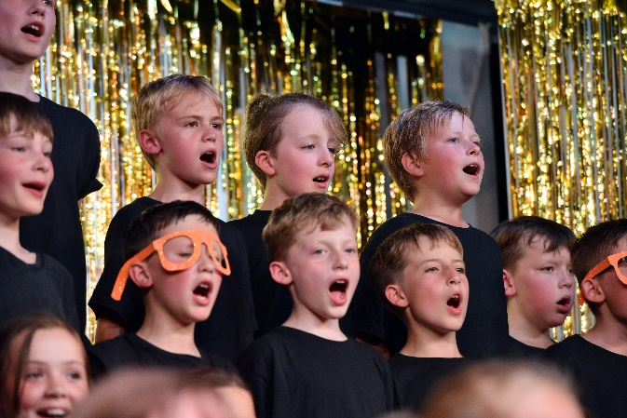

Religious Education
This is taught in accordance with the Norfolk Agreed Syllabus. Parents wishing to withdraw their child from Religious Education or the devotional part of morning assembly are invited to discuss the matter with the Headteacher. If you wish to find out more about literacy in school, speak to Mrs Bethell, the subject leader.

Art and Design
Our art and design curriculum aims to ensure that all pupils:

- produce creative work, exploring their ideas and recording their experiences
- become proficient in drawing, painting, sculpture and other art, craft and design techniques
- evaluate and analyse creative works using the language of art, craft and design
- know about great artists, craft makers and designers, and understand the historical and cultural development of their art forms.

Children will experience a variety of media, promoting awareness of colour, texture, design and an added element of art appreciation. They have the opportunity to express themselves artistically, based on studies of other cultures, contemporary artists and from direct observations.

Modern Foreign Languages.
Children are taught Modern Foreign Languages throughout Key Stage 2. A practical and spoken approach is always favoured. Our curriculum will provide an appropriate balance of spoken and written language and will lay the foundations for further foreign language teaching at key stage 3. It should enable pupils to understand and communicate ideas, facts and feelings in speech and writing, focused on familiar and routine matters, using their knowledge of phonology, grammatical structures and vocabulary. If you wish to find out more about literacy in school, speak to Miss Waters, the subject leader.

Geography
Our geography curriculum aims to inspire in pupils a curiosity and fascination about the world and its people that will remain with them for the rest of their lives. We try to equip pupils with knowledge about diverse places, people, resources and natural and human environments, together with a deep understanding of the Earth’s key physical and human processes.

History
Our history curriculum will help pupils gain a coherent knowledge and understanding of Britain’s past and that of the wider world. It should inspire pupils’ curiosity to know more about the past. We aim to equip pupils to ask perceptive questions, think critically, weigh evidence, sift arguments, and develop perspective and judgement.
History helps pupils to understand the complexity of people’s lives, the process of change, the diversity of societies and relationships between different groups, as well as their own identity and the challenges of their time. History frequently provides the central theme around which we develop natural links to literacy, ICT, art and the community. If you wish to find out more about literacy in school, speak to Mr Hunt, the subject leader.
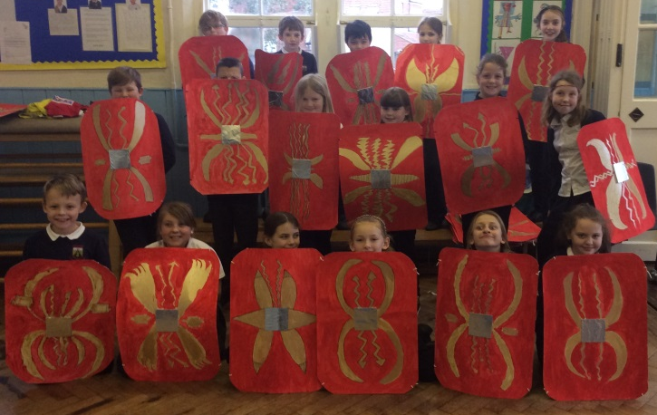

Spiritual, Moral, Social and Cultural Education
Our spiritual education aims to explore beliefs and experience, respect values and discover oneself and the surrounding world. It also encourages children to use their imagination and creativity when reflecting on their experiences
Moral education at Reedham aims to give pupils and understanding of right and wrong, help them to understand consequences, investigate moral and ethical issues and offer reasoned views.
Social education encourages children to use social skills in different contexts, work well with others, resolve conflicts and understand how communities work
Reedham’s cultural education enables children to appreciate cultural influences, participate in cultural opportunities and to understand, accept, respect and celebrate diversity. We use many visits out of school and invite many visitors into school to support and achieve these aims. If you wish to find out more about literacy in school, speak to Miss Spaul, the subject leader.

Music
In our music curriculum we aim to ensure that all pupils:
- perform, listen to, review and evaluate music across a range of historical periods, genres, styles and traditions, including the works of the great composers and musicians
- learn to sing and to use their voices, to create and compose music on their own and with others, have the opportunity to learn a musical instrument, use technology appropriately and have the opportunity to progress to the next level of musical excellence
- understand and explore how music is created, produced and communicated.

Singing and musical development is highly regarded at our school. Children have ample opportunities to explore musical learning and flourish in our nurturing environment. The school owns a range of tuned woodwind, brass, percussion and keyboard instruments. If you wish to find out more about literacy in school, speak to Mrs Bethell, the subject leader.
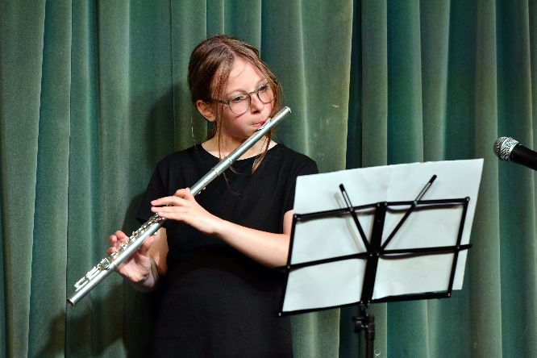

Instrumental and Musical Tuition
We are lucky to be able to provide music lessons with Mrs Ann Smith. She is able to teach children to learn to play the piano, violin, clarinet, flute, trombone, trumpet or cornet. They can also join the school orchestra who perform at a variety of venues throughout the year.
We also have a thriving singing culture, which also perform at events in the local community and beyond. Please contact the office for further details.

Personal, Social and Health Education (P.S.H.E.)
This is all about growing up, coming to terms with oneself as an individual and as a member of a community. It involves self-knowledge, the development of a positive self-image and working in a co-operative and positive way. Children are also taught to learn about health and safety, including aspects such as road, cycle, fire and internet safety. Much of this development is an integral part of every day school life. If you wish to find out more about literacy in school, speak to Miss Spaul, the subject leader.

Computing / ICT
The government has radically changed the approach to the teaching of information and communication technology in its new National Curriculum for 2014. We are fully prepared to embrace the new computing framework which will help to equip pupils to understand and change the world through logical thinking and creativity. Pupils will be encouraged to make links with mathematics, science, and design and technology.
More emphasis is now placed upon computer science, in which pupils are taught the principles of information and computation, and how digital systems work. At Reedham we use computing to equip pupils to use information technology to create programs, systems and a range of media. We also want our pupils to become digitally literate – able to use, and express themselves and develop their ideas through, information and communication technology.
Children have access to computers in all classrooms and a bank of 16 laptops means that there is a ratio of computers to children in school better than 1:3. When a class uses the computers they are often able to use a laptop or computer individually or at worst in a pair. If you wish to find out more about literacy in school, speak to Mr Hunt, the subject leader.

PE
This subject includes dance, gymnastics, athletics, games and swimming. The programme is designed to develop the physical skills necessary in preparation for later life and to instil an awareness of working together in teams.
The wearing of jewellery, other than a watch is not allowed. Any child with pierced ears should only wear studs whilst at school. The child should remove all jewellery during a PE lesson for safety reasons. Jewellery will be kept in a safe place for the duration of the lesson. P.E. kit consists of blue shorts and a white T-shirt.
A sports coach comes to school twice a week to teach high quality P.E. to all year groups and model excellence in P.E. coaching to members of staff. If you wish to find out more about literacy in school, speak to Mr Hunt, the subject leader.
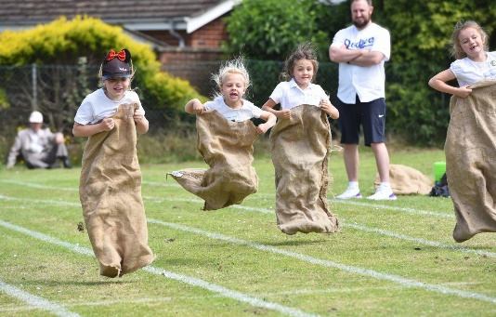

We are fortunate to have our own heated outdoor swimming pool with a uniform depth of 75cm and we take full advantage of it when the weather is suitable. Please ensure your child brings their swimming kit when his/her class is timetabled to use the pool. A waterproof bag is also needed.

SRE programme
The school has a policy for sex and relations. A programme has been incorporated into the curriculum. SRE is a lifelong learning about relationships, emotions, sex, sexuality and sexual health. Much of the work is included in the Seal and PHSE programmes as well as Science.
Parents are informed of the content of their child’s learning and parents may withdraw their children form certain aspects if they so wish.

Able, Gifted and Talented
We work hard to identify all the skills and talents in our children. The school has a Gifted and Talented register listing children who need special attention, challenge and differentiation in the curriculum.

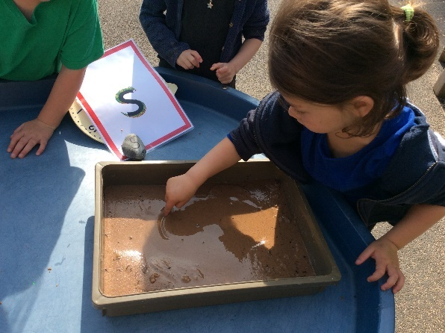
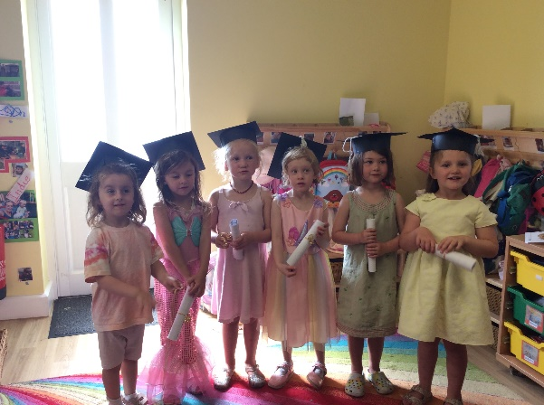
Children with Special Educational Needs
A child may need, at some time in their school life, extra help in a particular area of the curriculum. In these cases, we contact the child’s parents to explain the programme to be followed and also ask for co-operation in helping the child at home.

The school works closely with the special needs support team. In exceptional cases we need the assistance of the School’s Educational Psychologist. We sometimes recommend that an Educational Health and Social Care Plan procedure is followed in order to safeguard the child during his/her educational career. In these cases we work very closely with the parents.

There are many intervention programmes to help and support children individually or in small groups.

A link to the Norfolk Local Offer for children with SEND can be found on the school website and in the school office reception.

The Importance of Communication
At Reedham Primary and Nursery School, the relationship between parents/carers, pupils and the school is extremely important to us. We have a firm focus on nurturing the pupils’ positive relationships with both adults and each other. The aims of the school with regard to internal and external communication are detailed in our Communication Policy, along with the responsibilities of the school, staff members and parents/carers. This is available on our website and upon request from the school office.

Complaints Procedure
The Local Education Authority has established procedures in order that concerns of Parents about the school curriculum and related matters may be considered, and whenever possible, resolved.
This LEA panel is available should a Parent wish to raise a complaint relating to curriculum responsibilities of the Local Education Authority, or the Governing Body of the school.
In case of any anxiety, we do ask that in the first instance Parents arrange to see the Headteacher of the school in order that the matter may be dealt with in an informal manner. If there is dissatisfaction with the response, parents are then advised to contact or write a letter of complaint to the Chair of Governors, who will then deal with the complaint. As a last resort the complaint will be sent to a Local Education panel for formal consideration.
A copy of the Complaints Policy can be obtained from the school office. Further details of the authority’s procedures may be obtained from the Headteacher or the LEA.

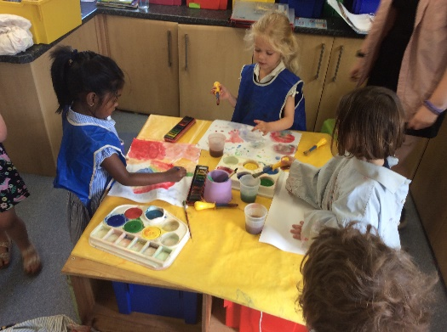
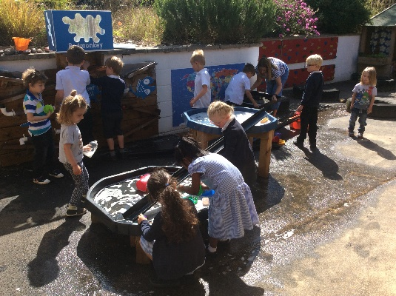

Current School Admissions Policy
Admission to our school is based on the academic year from 1st September to 31st August.
All eligible pupils for Reception may start full- time school during the academic year in which their fifth birthday falls. It is a legal requirement for pupils to be in full time education in the term following their fifth birthday.
Where parents opt to send their children part time in the first instance this is on a morning only basis unless the child has special requirements.

Norfolk Local Education Authority Admission Policy
In the event of over-subscription to a particular school, preference will be given to children living nearer to the school according to the following criteria in order of priority:

- Those living in the designated area served by the school.
- Those living outside the designated area served by the school but who will have an older sibling attending at the time of admission.
- Those living outside the designated area served by the school who for medical or other reasons have been professionally recommended to attend the school.
- Those living outside the designated area served by the school if space permits.

The History of Reedham Primary School
Reedham School is situated in a beautiful and prominent position in the heart of the village. The school was originally built in 1871 at a cost of £930 as a public elementary school and included a residence for the ‘School Master’. It was enlarged in 1881 for £200 and again in 1894 when a further £100 was spent to provide sufficient accommodation for 200 children. The School Master at that time was Mr Hallett Murfitt and the average attendance was 150. “Reedham formed a technical centre for six schools for cookery, laundry, gardening and woodwork.”

Kelly’s Directory of Norfolk, 1928.

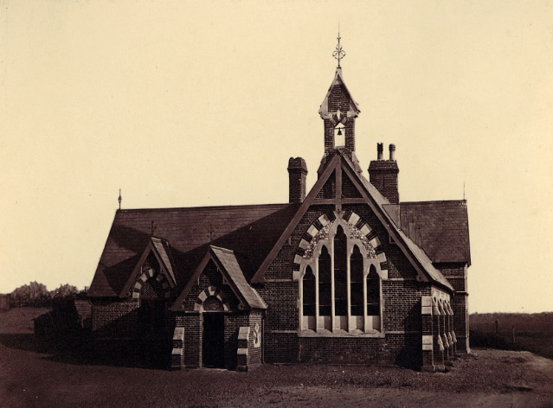
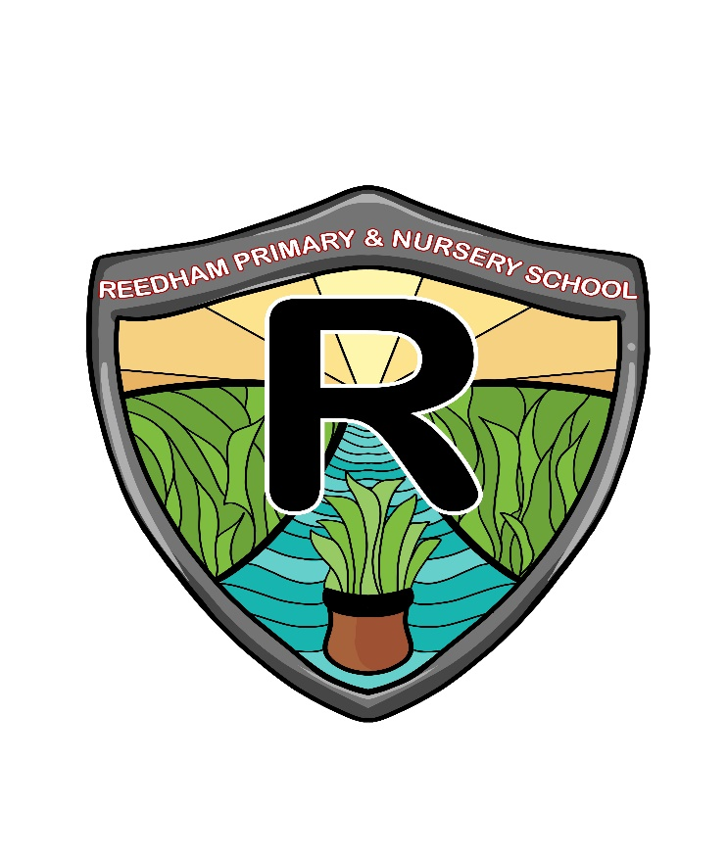
Reedham Primary School
School Hill
Reedham
Norwich
NR13 3TJ
Telephone: 01493 700271
Email: head@reedham.norfolk.sch.uk
Email: office@reedham.norfolk.sch.uk
Twitter: @ReedhamPrimary
Interim Headteacher: Miss Beth Spaul
Chair of Governors: Mrs De Jarvis

