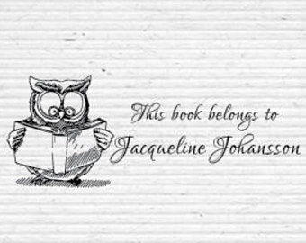

**Questions to Ask…..**

**During Reading**

How do you think the character feels?

What are your thoughts about the main character?

How do you think the story will end?

What do you think about this?

What ‘picture’ do you get when reading this book?

Are there any words you have found that you did not know before?

Can you summarise the main theme?

**After Reading**

What questions do you have?

How were problems resolved?

How did the author keep your attention?

What did you enjoy the least about the book?

What did you enjoy most about the book?

Would you have preferred a different ending, what would it be?



**Questions to Ask…..**

**During Reading**

How do you think the character feels?

What are your thoughts about the main character?

How do you think the story will end?

What do you think about this?

What ‘picture’ do you get when reading this book?

Are there any words you have found that you did not know before?

Can you summarise the main theme?

**After Reading**

What questions do you have?

How were problems resolved?

How did the author keep your attention?

What did you enjoy the least about the book?

What did you enjoy most about the book?

Would you have preferred a different ending, what would it be?



**Questions to Ask…..**

**During Reading**

How do you think the character feels?

What are your thoughts about the main character?

How do you think the story will end?

What do you think about this?

What ‘picture’ do you get when reading this book?

Are there any words you have found that you did not know before?

Can you summarise the main theme?

**After Reading**

What questions do you have?

How were problems resolved?

How did the author keep your attention?

What did you enjoy the least about the book?

What did you enjoy most about the book?

Would you have preferred a different ending, what would it be?

**Top Tips**

If they don’t want to read, find out why

Look for books based on their interests

Model it and discuss it

Visit the library

Have reading routines

Be patient and persevere

**Questions to Ask…..**

**Before reading**

Does the title suggest anything about the book?

What will you learn from reading this book?

Can you predict what will happen?

Do you have any expectations about the book?

What do the pictures tell you about the book?

**Top Tips**

If they don’t want to read, find out why

Look for books based on their interests

Model it and discuss it

Visit the library

Have reading routines

Be patient and persevere

**Questions to Ask…..**

**Before reading**

Does the title suggest anything about the book?

What will you learn from reading this book?

Can you predict what will happen?

Do you have any expectations about the book?

What do the pictures tell you about the book?

**Top Tips**

If they don’t want to read, find out why

Look for books based on their interests

Model it and discuss it

Visit the library

Have reading routines

Be patient and persevere

**Questions to Ask…..**

**Before reading**

Does the title suggest anything about the book?

What will you learn from reading this book?

Can you predict what will happen?

Do you have any expectations about the book?

What do the pictures tell you about the book?