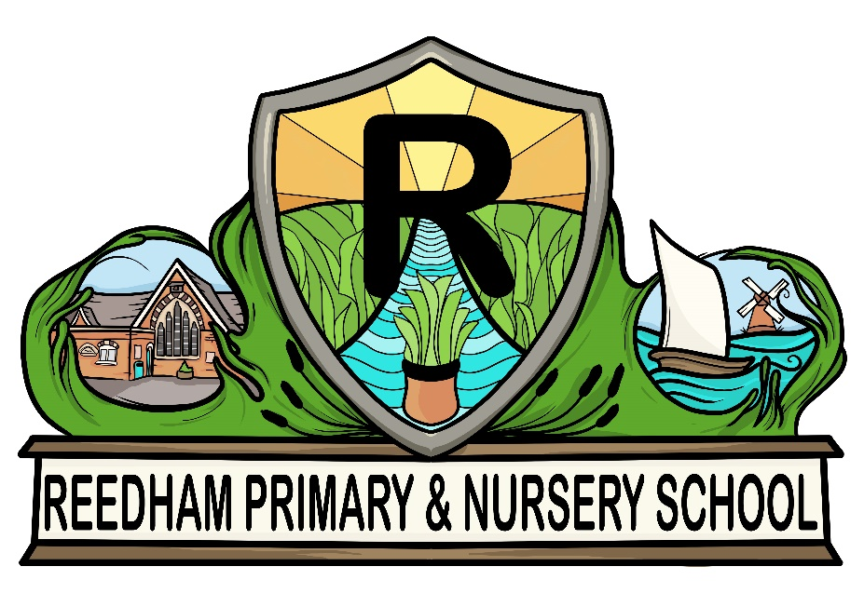 | Freedom of Information Act Publication Scheme  “by working together we learn, we achieve, we care”

Policy Consultation & Review

This policy is available on request from the school office.

This policy will be reviewed in full by the Governing Body. This policy was last reviewed and agreed by the Governing Body in May 2021. It is due for review in May 2024.

Signature:
Headteacher
Date:

Signature:
Chair of Governors
Date:

Introduction

This publication scheme commits Reedham Primary School and Nursery to make information available to the public as part of its normal business activities. The information covered is included in the classes of information mentioned below, where this information is held by Reedham Primary School and Nursery. Additional assistance is provided to the definition of these classes in sector specific guidance manuals issued by the Information Commissioner.

The scheme commits Reedham Primary School and Nursery:

- To publish or otherwise make available as a matter of routine, information, including environmental information, which is held by Reedham Primary School and Nursery and falls within the classifications below.

- To specify the information which is held by Reedham Primary School and Nursery and falls within the classifications below.

- To publish or otherwise make available as a matter of routine, information in line with the statements contained within this scheme.

- To produce and publish the methods by which the specific information is made routinely available so that it can be easily identified and accessed by members of the public.

- To review and update on a regular basis the information Reedham Primary School and Nursery makes available under this scheme.

- To produce a schedule of any fees charged for access to information which is made proactively available.

- To make this publication scheme available to the public.

- To publish any dataset held by the school that has been requested, and any updated versions it holds, unless the school is satisfied that it is not appropriate to do so; to publish the dataset, where reasonably practicable, in an electronic form that is capable of re-use; and, if any information in the dataset is a relevant copyright work and the public is the only owner, to make the information available for re-use under the terms of the Re-use of Public Sector Information Regulations 2015, if they apply, and otherwise under the terms of the Freedom of Information Act section 19. The term ‘dataset’ is defined in section 11(5) of the Freedom of Information Act. The term ‘relevant copyright work’ is defined in section 19(8) of that Act.

Classes of Information Published or Otherwise Made Available

Who we are and what we do.
Organisational information, locations and contacts, constitutional and legal governance.

What we spend and how we spend it.
Financial information relating to projected and actual income and expenditure, tendering, procurement and contracts.

What our priorities are and how we are doing.
Strategy and performance information, plans, assessments, inspections and reviews.

How we make decisions.
Policy proposals and decisions. Decision making processes, internal criteria and procedures, consultations.

Our policies and procedures.
Current written protocols for delivering our functions and responsibilities.

Lists and Registers.
Information held in registers required by law and other lists and registers relating to the functions of Reedham Primary School and Nursery.

The Services we Offer
Advice and guidance, booklets and leaflets, transactions and media releases. A description of the services offered.

The classes of information will not generally include:

- Information the disclosure of which is prevented by law, or exempt under the Freedom of Information Act, or is otherwise properly considered to be protected from disclosure.
- Information in draft form.
- Information that is no longer readily available as it is contained in files that have been placed in archive storage, or is difficult to access for similar reasons.

The method by which information published under this scheme will be made available

Where it is within the capability of Reedham Primary School and Nursery, information will be provided on a website or by hard copy. Where it is impracticable to make information available in these forms or when an individual does not wish to access the information in these forms, Reedham Primary School and Nursery will indicate how information can be obtained by other means and provide it by those means.

In exceptional circumstances some information may be available only by viewing in person. Where this manner is specified, contact details will be provided. An appointment to view the information will be arranged within a reasonable timescale.

Information will be provided in the language in which it is held or in such other language that is legally required. Where it is legally required to translate any information, Reedham Primary School and Nursery will do so.

Obligations under disability and discrimination legislation and any other legislation to provide information in other forms and formats will be adhered to when providing information in accordance with this scheme.

Charges which may be made for Information published under this scheme

The purpose of this scheme is to make the maximum amount of information readily available at minimum inconvenience and cost to the public. Charges made by Reedham Primary School and Nursery for routinely published material will be justified and transparent and kept to a minimum.

Material which is published and accessed on a website will be provided free of charge.

Charges may be made for information subject to a charging regime specified by Parliament.

Charges may be made for actual disbursements incurred such as:
- photocopying
- postage and packaging
- the costs directly incurred as a result of viewing information

Charges may also be made for information provided under this scheme where they are legally authorised, they are in all the circumstances, including the general principles of the right of access to information held by public authorities, justified and are in accordance with a published schedule or schedules of fees which is readily available to the public.

Charges may also be made for making datasets (or parts of datasets) that are relevant copyright works available for re-use. These charges will be in accordance with the terms of the Re-use of Public Sector Information Regulations 2015, where they apply, orwith regulations made under section 11B of the Freedom of Information Act, or with other statutory powers of the public authority.

If a charge is to be made, confirmation of the payment due will be given before the information is provided.

Payment may be requested prior to provision of the information.

Written Requests

Information held by Reedham Primary School and Nursery that is not published under this scheme can be requested in writing, when its provision will be considered in accordance with the provisions of the Freedom of Information Act.

