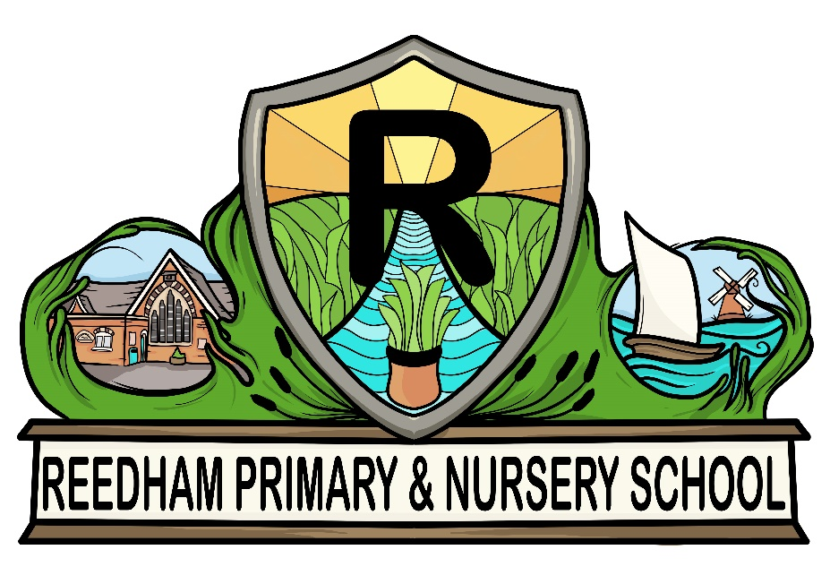 | Early Years Foundation Stage Policy  “by working together we learn, we achieve, we care”

Policy Consultation & Review
This policy is available on request from the school office.
This policy will be reviewed in full by the Governing Body every three years. This policy was last reviewed and agreed by the Governing Body in 2020. It is due for review in May 2023.
Signature:
Headteacher:
Date:
Signature:
Chair of Governors:
Date:

Introduction

‘Every child deserves the best possible start in life and support to fulfil their potential. A child’s experience in the early years has a major impact on their future life chances. A secure, safe and happy childhood is important in its own right and it provides the foundation for children to make the most of their abilities and talents as they grow up.

’Early Years Foundation Stage Profile -Department for Children, Schools and Families

The Early Years Foundation Stage applies to children from birth to the end of the reception year. At Reedham Primary School and Nursery, children are able to start nursery in the term after their second birthday and into reception in the September following their fourth birthday.

Early childhood is the foundation on which children build the rest of their lives. At Reedham Primary School and Nursery we greatly value the importance that the EYFS plays in laying secure foundations for future learning and development.

However, we also believe that early childhood is valid in itself as part of life. It is important to view the EYFS as preparation for life and not simply preparation for the next stage of education.

Aims & Objectives

We aim to support all children to become independent and collaborative learners. We aim to provide a broad and balanced curriculum that will enable each child to develop personally, socially, emotionally, spiritually, physically, creatively and intellectually to their full potential.

At Reedham Primary School and Nursery, we aim to:

- Provide a happy, safe, stimulating and challenging programme of learning and development for the children to experience as they begin their journey through school.
- Provide a broad, balanced, relevant and creative curriculum that will set in place firm foundations for further learning and development in Key Stage 1 and beyond and enable choice and decision making, fostering independence and self-confidence.
- Use and value what each child can do, assessing their individual needs and helping each child to progress.
- Develop excellent relationships with parents and carers to build a strong partnership in supporting their children.
- Provide a caring and inclusive learning environment which is sensitive to the requirements of the individual child including those who have additional needs.

The early-years education we offer our children is based on the following principles:

- It builds on what our children already know and can do;
- It ensures that no child is excluded or disadvantaged;
- It offers a structure for learning that has a range of starting points, content that matches the needs of young children, and activities that provide opportunities for learning both indoors and outdoors;
- It provides a rich and stimulating environment;
- It acknowledges the importance of a full working partnership with parents and carers.

The Early Years Foundation Stage is based on four themes:

- A Unique Child
- Positive Relationships
- Enabling Environments
- Learning and Development

A Unique Child

At Reedham Primary School and Nursery we recognise that every child is a competent
learner who can be resilient, capable, confident and self-assured. We recognise that children develop in individual ways and at varying rates. Children’s attitudes and dispositions to learning are influenced by feedback from others; we use praise and encouragement, as well as celebration and rewards, to encourage children to develop a positive attitude to learning.

Inclusion - We value the diversity of individuals within the school and believe that every child matters. All children at Reedham Primary School and Nursery are treated fairly regardless of ethnicity, religion, attainment, age, disability, gender or background.
. All families are valued within our school.

We give our children every opportunity to achieve their personal best and planning is adapted to meet the needs of all groups and abilities. We do this by taking account of our children’s range of life experiences when we are planning for their learning.

In the Foundation Stage we set realistic and challenging expectations keyed to the needs of our children, so that most achieve the Early Learning Goals by the end of the stage. We do this through:
- Planning opportunities that build upon and extend children’s knowledge, experience and interests, and develop their self-esteem and confidence;
- Using a wide range of teaching strategies based on children’s learning needs;
- Providing a wide range of opportunities to motivate and support children and to help them learn effectively;
- Offering a safe and supportive learning environment in which the contribution of all children is valued;
- Employing resources which reflect diversity and are free from discrimination and stereotyping;
- Planning challenging activities to meet the needs of both boys and girls, of children with special educational needs, of children who are more able, of children with disabilities and of children from all social and cultural backgrounds.
- Monitoring children’s progress and taking action to provide support as necessary (such as referrals to speech therapy) as necessary.
- Working closely with parents, carers and other outside agencies to ensure all children’s needs are met and we enable them to access the curriculum and make good progress.

Positive Relationships

At Reedham Primary School and Nursery we recognise that children learn to be strong, confident and independent from being in secure relationships. We aim to develop caring, respectful, professional relationships with the children and their families.

Parents as Partners - We recognise that parents/carers are children’s first and most enduring educators and we value being partners with them in their child’s education through:

- Talking to parents/carers before their child starts school at our induction meeting.
- Providing a handbook of information prior to admission.
- Outlining the school’s expectations in the Home-School agreement.
- Inviting new starters to spend time in Reception Class for sessions during the summer term if they are not already in Nursery.
- Providing an induction meeting for parents/carers to meet with staff to discuss school routines, expectations and to answer any questions parents/carers may have.
- Holding a parent consultation early in the academic year to establish how a child is settling into the school environment.
- Operating an open door policy for parents/carers with any queries or concerns. Conversely, if Foundation staff have concerns about the progress of a child, they will immediately approach parents and carers to discuss them.
- Written contact through, for example, a reading record and school newsletters.
- Inviting parents to attend informal meetings about areas of the curriculum, such as phonics or reading.
- Having regular access to their children’s online ‘Learning Journey’ and valuing the on-going contributions that they make to them.
- Offering parent/teacher consultation meetings each year at which their child’s progress is discussed.
- Sending a written report on their child’s attainment and progress at the end of their time in reception.
- Asking parents to sign a generic permission form for visits, food tasting and photographs etc.
- Inviting parents to a range of activities throughout the school year such as assemblies, workshops, Christmas Nativity play and sports day etc.
- Offering opportunities for parents and carers to visit the school on a volunteer basis to assist with the children’s learning e.g. hearing readers.

Enabling Environments

At Reedham Primary School and Nursery we recognise that the environment plays a key role in supporting and extending the children’s development, where the children feel confident, secure and challenged. The children have daily access to an indoor and outdoor environment with planned continuous provision.

Play-based learning is paramount and children have opportunities to direct their own learning with planned opportunities provided by staff.

We plan a learning environment, both indoors and outdoors, that encourages a positive attitude to learning and reflects the individual’s interests, passions and abilities. We use materials and equipment that reflect both the community that the children come from and the wider world. We encourage the children to make their own selection of the activities on offer, as we believe that this encourages independent learning. We ensure that resources and spaces are safe to use and checked regularly.

Learning and Developing

The EYFS Curriculum – Our curriculum for the Foundation Stage reflects the areas of learning identified in the Early Learning Goals.

There are seven areas of learning and development that must shape educational provision in Early Years settings. All areas of learning and development are important and inter-connected. None of the areas of learning can be delivered in isolation from the others. Our children’s learning experiences enable them to develop competency and skill across a number of learning areas.

They require a balance of adult led and child initiated activities in order for most children to reach the levels required at the end of EYFS. Three areas are particularly crucial for igniting children’s curiosity and enthusiasm for learning, and for building their capacity to learn, form relationships and thrive.

The three Prime areas are:

- Personal, Social and Emotional Development
- Communication and Language
- Physical Development

Staff will also support children in four specific areas, through which the three prime areas are strengthened and applied.

Specific Areas:

- Literacy
- Mathematics
- Understanding the world
- Expressive arts and design

Children’s development levels are assessed and as the year progresses, the balance will shift towards a more equal focus on all areas of learning, as children grow in confidence and ability within the three prime areas.

However, if a child’s progress in any of the prime areas gives cause for concern, staff will discuss this with the child’s parents/carers and agree how to support the child.

Reception pupils also participate in daily phonics sessions.

Characteristics of Effective Learning

We ensure that our environment and delivery of the curriculum incorporates the three characteristics of effective teaching and learning:

Playing and exploring - children will have opportunities to investigate and experience things, and ‘have a go’.

‘Children’s play reflects their wide ranging and varied interests and preoccupations. In their play children learn at their highest level. Play with peers is important for children’s development.’

Through play, our children explore and develop learning experiences, which help them make sense of the world. They practise and build up ideas, learn how to control themselves and understand the need for rules. They have the opportunity to think creatively alongside other children as well as on their own. They communicate with others as they investigate and solve problems.

Active learning - children will have time and space to concentrate and keep on trying if they encounter difficulties, and enjoy their achievements.

‘Children learn best through physical and mental challenges. Active learning involves other people, objects, ideas and events that engage and involve children for sustained periods.’

Active learning occurs when children are motivated and interested. Children need some independence and control over their learning. As children develop their confidence, they learn to make decisions. It provides children with a sense of satisfaction as they take ownership of their learning.

Creating and thinking critically - we encourage and support children to have and develop their own ideas, make links between ideas, and develop strategies for doing things.

“When children have opportunities to play with ideas in different situations and with a variety of resources, they discover connections and come to new and better understandings and ways of doing things. Adult support in this process enhances their ability to think critically and ask questions.”

Children should be given the opportunity to be creative through all areas of learning. Adults can support children’s thinking and help them make connections by showing interest, offering encouragement, clarifying ideas and asking open ended questions. Children can access resources and move around the classroom freely and purposefully to extend their learning.

Planning

The Early Learning Goals provide the basis for planning throughout the Foundation Stage. The class teacher uses the national schemes of work, where appropriate, to support their planning for individual children. The planning objectives within the Foundation Stage are from the Development Matters Statements from the Early Years Foundation Stage document. The planning is based upon themes with discrete phonics, maths and reading directed teaching. However, planning, which is based upon a different topic which is identified as vehicle of interest to deliver the children’s next steps in learning, also therefore responds to the needs, achievement and interest of the children. Our medium-term planning identifies the intended learning, with outcomes, for children working towards the Early Learning Goals.

Observations

Foundation Stage staff use observations as the basis for planning. Staff are skilled at observing children to identify their achievements, interests and next steps for learning. These observations then lead the direction of the planning. Relevant and significant observations are recorded in the children’s online Learning Journeys.

Assessment

In Nursery the children’s level of development is recorded using the Development Matters age-bands. During the first term in Reception, the teacher assesses the ability of each child using a baseline assessment. These assessments allow us to identify patterns of attainment within the cohort, in order to adjust the teaching programme for individual children and groups of children.

The Foundation Stage Profile is the nationally employed assessment tool that enables teachers to record their observations at the end of the Foundation Stage, and to summarise their pupils’ progress towards the Early Learning Goals. It covers each of the seven areas of learning contained in the curriculum guidance for the Foundation Stage.

We record each child’s level of development against the 17 early Learning goals as Emerging, Expected or Exceeding. We make regular assessments of children’s learning, and we use this information to ensure that future planning reflects identified needs.

Assessment in the Foundation Stage takes the form of both formal and informal observations, photographic evidence and through planned activities. Assessment is completed regularly and involves both the teacher and other adults, as appropriate. The collection of assessment data in the Foundation Stage Profile is a statutory requirement.

The teacher keeps progress records, online learning journals and records examples of each child’s work. These learning journeys contain a wide range of evidence that parents have the opportunity to look at as and when they wish.

Tracking grids are updated at the end of each half term. This provides a summary sheet for each child which feeds into the whole-school assessment and tracking process. We record each child’s level of development to be emerging, developing or securely working within the Development Matters age-bands and Early Learning Goals.

At the end of the final term in Reception we send a summary of these assessments to the LA for analysis. We share this information with parents at consultation meetings and in the end-of-year report.

Parents receive an annual written report that discusses the child’s characteristics of effective learning and offers brief comments on each child’s progress in each area of learning. It highlights the child’s strengths and development needs, and gives details of the child’s general progress. We complete these in June, and send them to parents in early July each year.

The Learning Environment

The Foundation Stage classroom is organised to allow children to explore and learn securely and safely. There are specific areas where the children can be active, be quiet, creative etc.

Children have access to both inside and outside areas across the day; this has a positive effect on the children’s development. Being outdoors offers opportunities for doing things in different ways and in different scales than when indoors. The children can explore, use their senses and be physically active and exuberant. All areas of the curriculum can be explored outside.

Teaching & Learning Styles

The features of effective teaching and learning in our school are defined in our policy on teaching and learning. They apply to teaching and learning in the Foundation Stage just as much as they do to the teaching and learning in Key Stage 1 or 2.

The more general features of good practice in our school that relate to the Foundation Stage are:
- the partnership between teachers and parents, carers and other settings that helps our children to feel secure at school, and to develop a sense of well-being and achievement;
- the understanding that teachers have of how children develop and learn, and how this must be reflected in their teaching;
- the range of approaches that provide first-hand experiences, give clear explanations, make appropriate interventions, and extend and develop the children’s play, talk or other means of communication;
- the carefully planned curriculum that helps children achieve the Early Learning Goals by the end of the Foundation Stage;
- the provision for children to take part in activities that build on and extend their interests, and develop their intellectual, physical, social and emotional abilities;
- the encouragement for children to communicate and talk about their learning, and to develop independence and self-management;
- the support for learning, with appropriate and accessible space, facilities and equipment, both indoors and outdoors;
- the identification, through observations, of children’s progress and future learning needs, which are regularly shared with parents;
- the clear aims of our work, and the regular monitoring of our work to evaluate and improve it;
- the regular identification of training needs for all adults working at the Foundation Stage.

Safeguarding & Welfare

‘Children learn best when they are healthy, safe and secure, when their individual needs are met, and when they have positive relationships with the adults caring for them.’(Statutory Framework for EYFS 2014)

At Reedham Primary School and Nursery, we understand that we are legally required to comply with welfare requirements as stated in the Statutory Framework for Early Years Foundation Stage 2017.

- To provide a setting that is welcoming, safe and stimulating where children can grow in confidence;
- Promote good health;
- Manage behaviour effectively in a manner appropriate for the children’s stage of development and individual needs;
- To ensure that all adults who look after the children, or who have unsupervised access to them, are suitable to do so;
- Ensure that the setting, furniture and equipment is safe and suitable for the purpose it was intended for;
- Maintain records, policies and procedures required for the safe efficient management of the setting and to meet the needs of the children.

Keeping Safe - It is important to us that all children in the school are ‘safe’. We aim to educate children on boundaries, rules and limits and to help them understand why they exist. We provide children with choices to help them develop this important life skill. We encourage children to take risks and highlight the importance of keeping themselves safe by teaching them how to recognise and avoid hazards. We aim to protect the physical and psychological well-being of all children. (See our Safeguarding Children Policy).

Good Health - All children are provided with a healthy snack each day as well as being given the choice of milk. They have access to water at all times.

Intimate Care - “Intimate” care is any care which involves washing, touching or carrying out an invasive procedure that most children are able to carry out themselves. However, depending on a child’s age and stage of development, they may need some support, for example dressing, wiping their bottom after using the toilet and changing underwear following an accident. In most cases, intimate care is to do with personal hygiene.

Every child has the right to privacy, dignity and a professional approach from all staff when meeting their needs and it is important that staff work in partnership with parents to give the right support to an individual child.

Monitoring and Review

It is the responsibility of those working in Nursery and Reception to follow the principles stated in this policy. The Head teacher will carry out monitoring on EYFS as part of the whole school monitoring schedule. The Governing Body will also be part of this process.

Links to other policies

Intimate Care
Transition
Administration of Medicines
Attendance
Safeguarding
Accessibility

