Special Educational Needs (SEN) Information Report
for Reedham Primary School 2017-18

Part of the Norfolk Local Offer for Learners with SEN

If you would rather listen to this than read it there is a video link here. (Available shortly)

Introduction

Welcome to our SEN information report.
This is part of the Norfolk Local Offer for learners with Special Educational Needs (SEN.)

The local offer is where parents can find out what is available in Norfolk to support their child. http://www.schools.norfolk.gov.uk/Pupil-needs/Norfolk-SENCOs/Our-local-offer/index.htm

Schools have a legal duty to publish an SEN policy and information on their website about how they support pupils with SEN. The information published must be updated annually. The required information is set out in the draft SEN regulations which can be found here.

Who to Contact

At Reedham Primary we are committed to working together with all members of our school community. Our school offer has been produced with pupils, parents/carers, governors, and members of staff. We would welcome your feedback and future involvement in the review of our offer, so please do contact us. The best people to contact this year are:

SEN and Parent Governor: Sam Bethell
SENCO, Headteacher and School Council Link: Chris Edwards

If you think your child may have SEN please speak to their Class Teacher or contact Chris Edwards our SENCO and Headteacher on 01493 700 271.

The Acle Cluster of Schools, to which Reedham Primary School belongs, also employs a Cluster SENCO.
Her name is Sarah Gentle and she can be contacted via email at: Sgentle5wr5@nsix.org
Alternatively, Sarah works half a day a fortnight at Acle Primary School and can be contacted through Acle Primary School on 01493 750 322. It is also possible to leave a message with the office at Acle who will forward this to her.

This is What Our School Has To Offer

At Reedham Primary, we value: Learning for all.

We want all adults and children to participate in learning. We celebrate all members of our
community. Our aim is to create a sense of welcome and an inclusive culture in our
school. This includes being responsive to the diversity of children’s backgrounds, interests,
experience, knowledge and skills.
We value high quality teaching for all learners, including those identified with SEN, and actively monitor teaching and learning in the school. For more information on our approach, please see our teaching and learning policy.
Our school improvement plan is about developing learning for all and includes continued professional development (CPD) opportunities for all staff. Our plan for 2015-17 can be found here.

How we identify SEN

At different times in their school career, a child or young person may have a special educational need. The Code of Practice defines SEN as:

“A child or young person has SEN if they have a learning difficulty or disability which calls for special educational provision to be made for them. A child of compulsory school age or a young person has a learning difficulty or disability if they:

- have a significantly greater difficulty in learning than the majority of others of the same age: or
- have a disability which prevents or hinders them from making use of educational facilities of a kind generally provided for others of the same age in mainstream schools or mainstream post-16 institutions.”

Every teacher is expected to teach at a range of levels that reflect the pupils’ range of interest and understanding; this is called the normal differentiated curriculum. If your child is identified as having SEN, our job is to offer them something “extra” that is ‘additional to or different from’ the normal differentiated curriculum. Any “extra” provision or intervention is designed to overcome the barrier to their learning.

Learners can fall behind in school for lots of reasons. They may have been absent from school, they may have attended lots of different schools and not had a consistent opportunity to learn. They may not speak English very well or at all or they may have worries that distract them from learning.

So, not all vulnerable learners have SEN. Only those with a learning difficulty that require special educational provision will be identified as having SEN.

At Reedham Primary we are committed to ensuring that all learners have access to learning opportunities, and for those who are at risk of not learning, the school has a responsibility to support via a range of interventions.

Our SEN profile for 2017 – 2018 shows that we have 28% of children having a Special Educational Needs but no children with a statement or an Education Health and Care Plan.

Assessing SEN at Reedham Primary
Class Teachers, support staff, parents/carers and the child themselves will be the first to notice a difficulty with learning. This then triggers an assessment that involves the child, their parents/carer and their Teacher. The Special Educational Needs Co-ordinator (SENCO) explores what is causing difficulties with learning using a range of assessments. These are the same across our cluster.

For some learners we may want to seek advice from specialist teams. In our school and cluster we use various specialist services. Some are provided by Norfolk County Council, which are described on the Local Offer website available here.

Reedham Primary as part of the Acle Cluster, has paid for 2017-18 support from:

Educational Psychology Service:
Trainee Educational Psychologist: Sue Ackerley,
Specialist Learning Support Teacher Anna Pearson 39 hours a year
Respectrum: Sue Sengupta

Cluster Host Lead: Sarah Gentle – 3.25 hours fortnightly

We also employ Learning Support Assistants who deliver the interventions in the provision map as co-ordinated by our SENCO/Headteacher.

What we do to Support Learners with SEN at Reedham Primary

Every Teacher is expected to adapt their classroom, teaching and resources to help children with SEN make the best progress they can. To enable this to happen, the SENCO and Senior leadership team support teachers by providing advice and training. There is regular monitoring and observations that identify teachers who may need help supporting pupils with SEN in their class.
The Teacher Standards 2012 detail the expectations on all teachers, and we at Reedham Primary School are proud of our Teachers and their development. The Teacher standards are available here.

Our Teachers will use various strategies to help children with SEN join in. This might include using:
- Visual timetables
- Writing frames
- Tablets, lap tops or other alternative recording devices
- Positive behaviour rewards system
- Use of overlays

The type of support is dependent on the individual’s needs. This support is on a chart called a “provision map”. It does not detail the individual learner names, but describes the interventions and actions that we use at Reedham Primary to support learners with SEN. We modify the provision map regularly, and it changes every year, as our learners and their needs change.

We share the provision map with our colleagues in the Acle Cluster so we can learn from each other, and show others what we offer. Our Cluster SEN host, Sarah Gentle, encourages and supports Acle schools to work together. The aim is to make sure your child gets the same opportunities whichever of the eight schools they attend.

Our provision map is shared with Governors who check we are doing what we say and that it makes a difference to the progress of children with SEN.

Funding for SEN

Reedham Primary receives funding directly to the school from the Local Authority to support the needs of learners with SEN. The amount can be seen in something called the SEN memorandum. We received £19,849 in 2017-17 for SEN.

The Acle cluster of schools also receive money from the Local Authority as ‘top up’ funding for learners who need support that is more than that available to the school. The Acle cluster funding for 2016-17 was £108,317

If you would like any further information on SEN in the Acle cluster please contact our Cluster SEN host: sgentle5wr5@nsix.org

How do we find out if this support works?

Checking children’s progress is an integral part of our school. We follow the ‘assess, plan, do, review’ cycle.

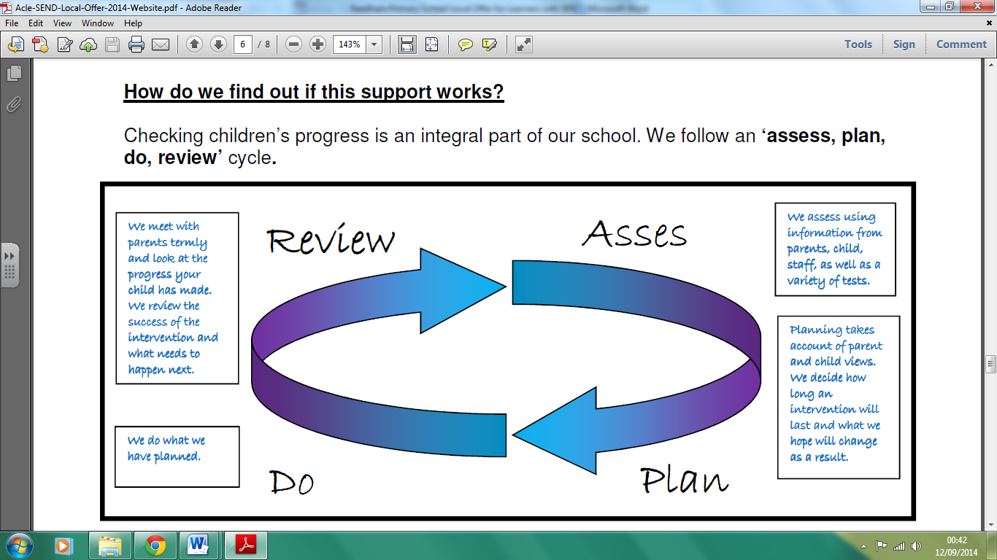
Assess

It is important to us that parents/carers and children are involved in each step. The SENCO, Teacher, parent/carer and learner will talk together before we decide what kind of help we give a child. We also agree what we expect to be different following this intervention. The child’s level is recorded before and after the intervention to see if the extra support has made a difference to their learning.

Children, Parents/carers and the Teaching and Support Staff will be directly involved in reviewing progress. This review can be built in to the intervention itself and is part of a formal meeting held once a term. This is when we all discuss progress and next steps. If a child has a Statement or an Education Health and Care Plan (EHC plan,) this is formally reviewed annually, as well as in less formal termly meetings.

The SENCO checks we are only using interventions that work. The data is shared with the Acle cluster, so the SENCOs in our eight schools are able to choose high quality provision.
All data is scrutinised by the senior leadership teams, governors, local authority and Ofsted.

Other Opportunities for Learning

All learners should have the same opportunity to take part in extra-curricular activities. At Reedham Primary School in 2017-18 we are offering a range of additional clubs and activities. These can be found on our extended school web page available here.

We are committed to making reasonable adjustments to ensure participation for all, so please contact our extended school co-ordinator to discuss specific requirements. Please email: acle.cluster@yahoo.co.uk

All staff at Reedham Primary School have regular training on the Equality Act 2010. This legislation places specific duties on schools, settings and providers including the duty not to discriminate, harass or victimise a child or adult linked to a protected characteristic defined in the Equality Act and to make ‘reasonable adjustments.’

The Equality Act 210 definition of disability is:

“A person has a disability for the purposes of this Act if (s)he has a physical or mental impairment which has a substantial and long-term adverse effect on his ability to carry out normal day-to day activities.”
Section 1(1) Disability Discrimination Act 1995

This definition of disability in the Equality Act includes children with long term health conditions such as asthma, diabetes, epilepsy, and cancer. Children and young people with such conditions do not necessarily have SEN, but there is a significant overlap between disabled children and young people and those with SEN. Children and young people may therefore be covered by both SEN and disability legislation.

For more information about the Equality Act, the protected characteristics or duties on public bodies, please click here.

If you are worried your child is being bullied

Children with special educational needs can be vulnerable to bullying. Reedham Primary School takes all incidents of bullying very seriously and its approaches are explained in the anti-bullying policy here. Please contact a member of staff as soon as possible if you are worried your child may be bullied.

Useful contacts for further information and advice about anti-bullying

www.childline.org.uk/Bullying
www.kidscape.org.uk
www.anti-bullyingalliance.org.uk
www.kidpower.org

The county employs a senior educational psychologist lead on anti- bullying called Rita
Adair. She can be contacted at rita.adair@norfolk.gov.uk

Preparing for the next step

Moving on is a part of life for all learners. This can be transition to a new class in school, having a new teacher, or moving on to another school. Reedham Primary School works in partnership with children, families and other providers to plan for and provide positive transitions for our learners with SEN.

Moving classes will be discussed with you and your child in our summer term review meeting. Transition to secondary schools will be discussed in the summer term of their Year 5, to ensure time for planning and preparation.

Have your say
Reedham Primary is our community school. We welcome everyone helping to shape and develop provision for all of our learners, aiming at achievement for all. This SEN report sets out Reedham’s offer to children with SEN which will be reviewed annually. We welcome your involvement in the process for next year’s report. Come and help us make a difference for your child and others.

Useful links
www.norfolk.gov.uk/SEN
Parent Partnership
www.dfe.gov.uk
Local links
Autism Anglia
Shine
Children’s Centre
CAMHS
Point 1 etc
Riding for the disabled
Hamlet Centre
Acle Voluntary Association
Nelsons journey
Indigo Centre
Young carers
Parent Support Group at Trinity Sure Start

Extra curricular activities for children (some of the sporting clubs are held over a rolling program of years)

Orchestra
Singing Club
Zumba/Street Dance
Cheerleading
Craft Club
Drama
Multi-skills
Football
Handball
Fencing
Tennis
Dodgeball
Archery
Karate at Ormesby
Badminton at Blofield
Acle United
Beavers
Scouts
Rainbows
Brownies

