Headteacher: Mr Chris Edwards
Reedham Primary School
School Hill, Reedham, Norwich NR13 3TJ.
Telephone Number: 01493 700271
Fax Number: 01493 701860
E-mail: office@reedham.norfolk.sch.uk.

Newsletter
Friday 24th November 2017

School Trip to Norwich Cathedral
On Wednesday 22nd November, we took the children to Norwich Cathedral. There, we got the opportunity to learn about the life of monks (which fitted into our Middle Ages history work) and the Great Fire of London. As somebody who prides himself in knowing lots about our local heritage, I was fascinated by the new things we learned about the cathedral. Hopefully, the children can relay lots of information back to you about their trip and not only the fact that both myself and Mr Bass were dressed up as Prior Monks!
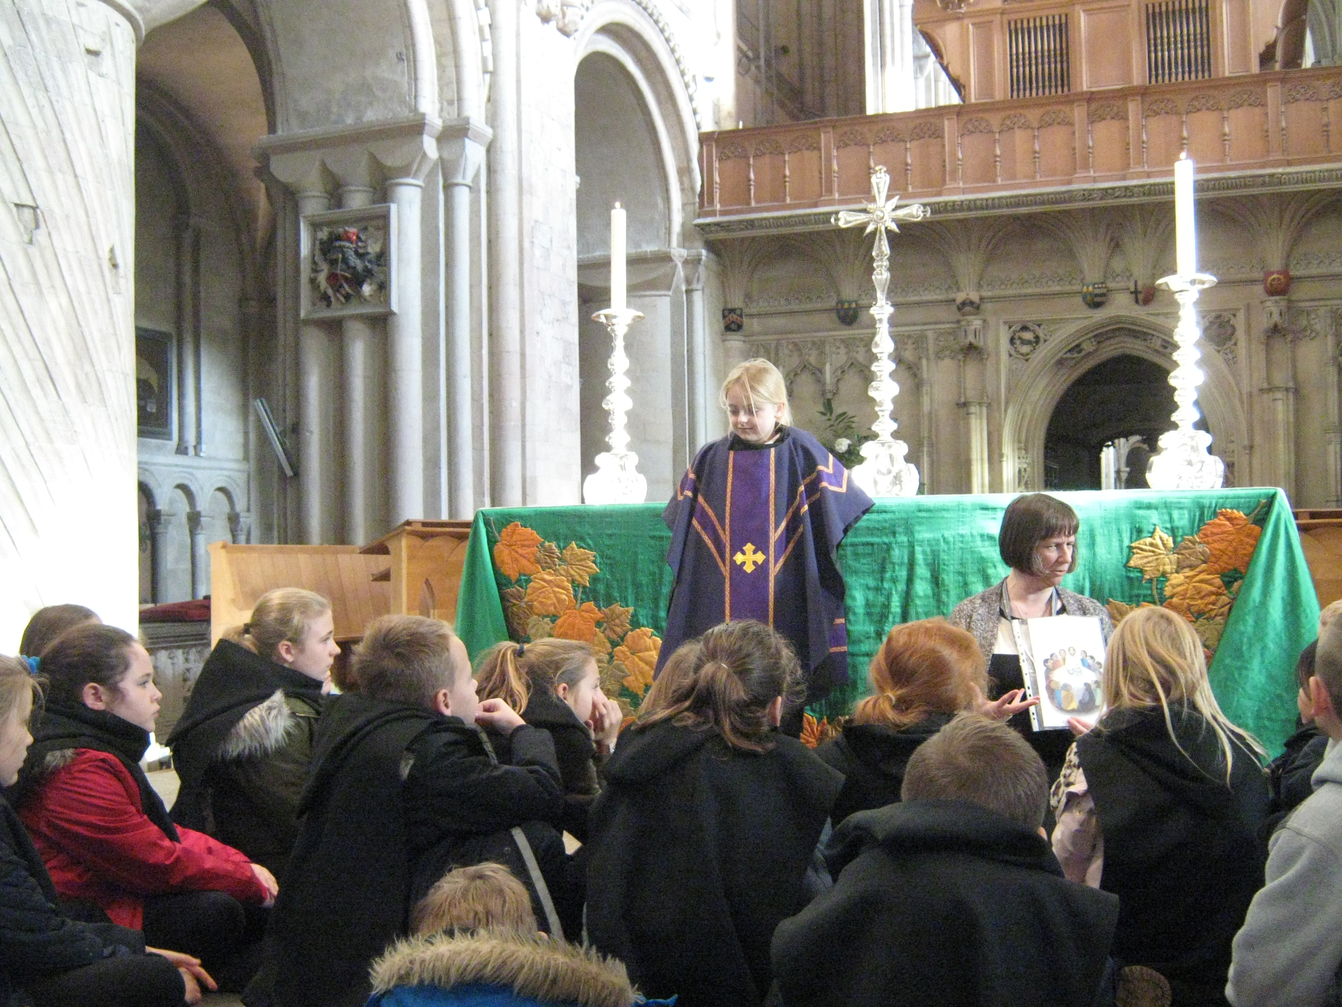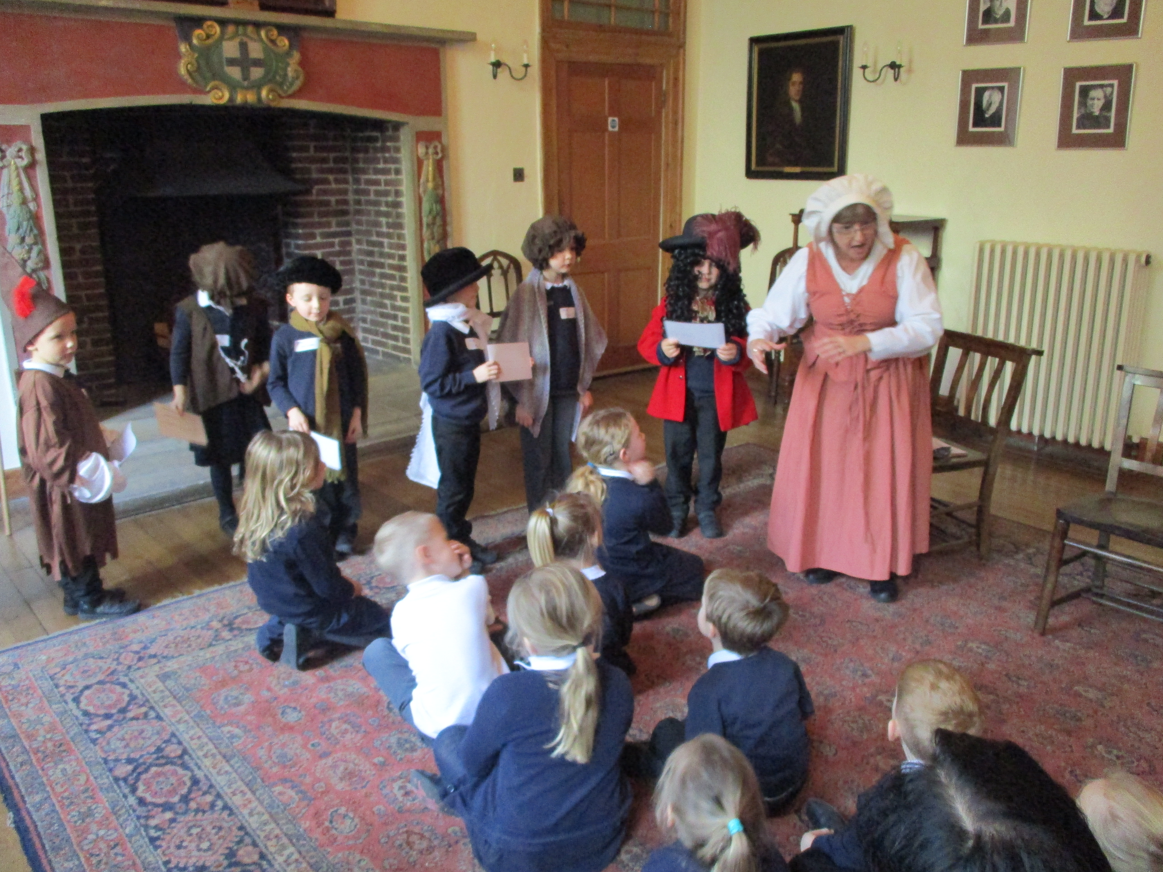

Is a timely reminder

Residential School Trip to Horstead
I am pleased to announce that we had just enough positive replies to the idea of a KS2 residential school trip next term to Horstead Activity Centre. For those parents/children who have initially said no, there is still time to change your mind. It will be a wonderful opportunity for the children to experience a wide range of physical activities and team bonding experiences. More information will come out soon so watch this space.
Toys in School
Can we ask that you don’t let your child bring toys into school. Unfortunately, they usually end up causing arguments because other children want to play with them too. There is also the added issue of a toy getting lost or damaged causing further problems. There are more than enough toys and games in school for the children to use without the need to bring more in from home.

Netball/Basketball Competition
We took two teams to the Netball and basketball competition and achieved our best ever results at both. Despite being the smallest school in the cluster, our basketball shooters came third and won bronze medals.
Our Netball team did one better. Their teamwork and will to win shone through and they ended up finishing in second place, winning four games, drawing one and losing one. It was an exceptional result and they played brilliantly all afternoon.
In their first game they beat Freethorpe 2-0. They then went on to beat Acle 1-0 and draw with Cantley 0-0. A loss to eventual winners Lingwood didn’t stop them and they came back to beat both Fleggburgh 2-0 and Fairhaven 2-1. It was a fantastic achievement by all of the children.

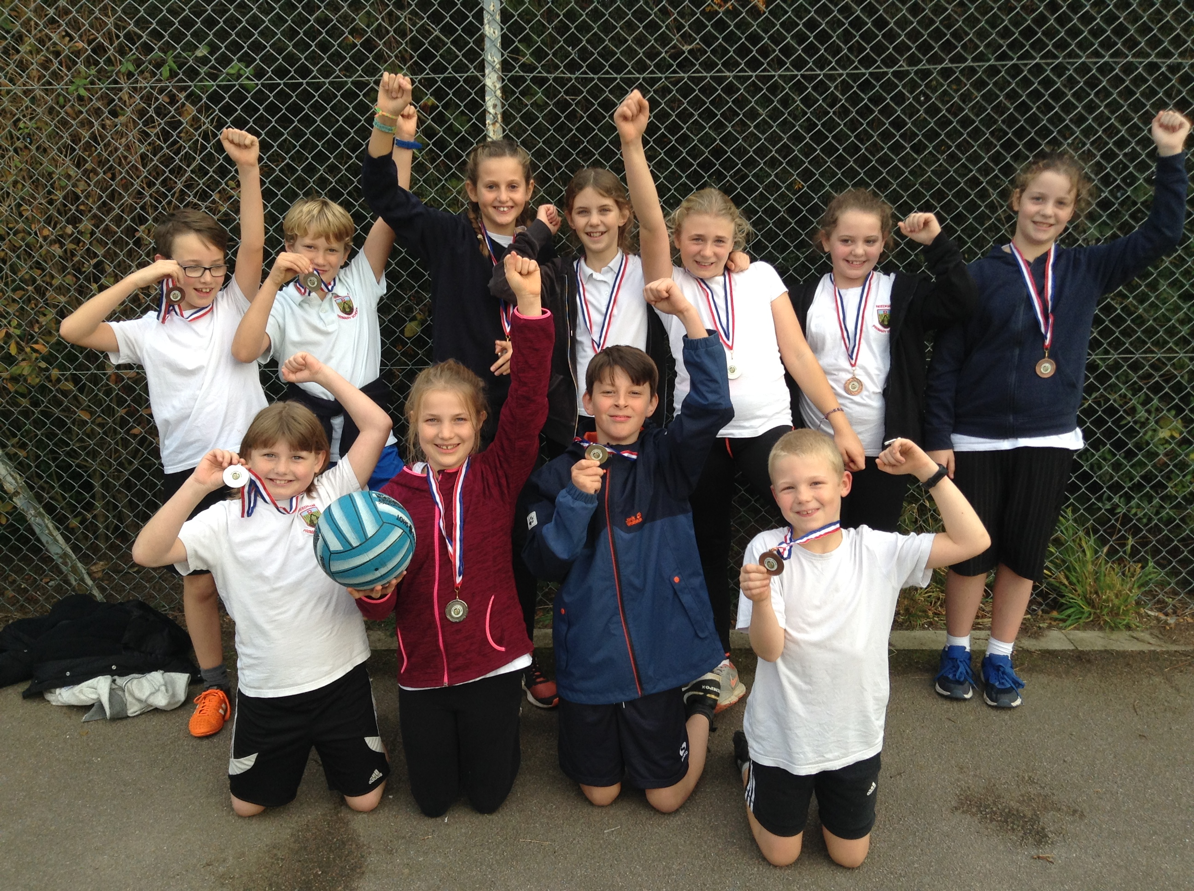

Y6 Transition Day to Acle Academy
On Thursday 23rd November, Acle Academy hosted another transition day for all the children in Y6 in the Acle cluster of schools. This time the focus was on Design and Technology. The children reported back positively about the day and are already looking forwards to the next one after Christmas.

Internet Safety
PC Ian Kennedy and PCSO Bob Hall visited the school to talk about the importance of staying safe in an ever changing technological world. Their work follows on from our own extensive and ongoing coverage of internet safety. All children in school get to know about Hector’s World – a series of short programs aimed at younger children telling them of the importance of keeping personal information safe online. You can visit this at: www.thinkuknow.co.uk/5_7/hectorsworld/
The older children are taught to be SMART, using the SMART crew rules: Safe – What should you keep safe Meeting – Be careful when meeting up Accept – What should you accept Reliable - What is reliable information to use Tell – Who should you tell if something or someone is bothering you
These rules are accompanied by online videos that can be found at ChildNet or through googling SMART Crew. www.childnet.com/resources/the-adventures-of-kara-winston-and-the-smart-crew

Maths Whizz Reminder
We are really trying to push the use of MathsWhizz out of school as well as in school. We can see the huge impact it is having for those children using it regularly. If you know your child is not using it on a regular basis please encourage them to do so. It can only have a positive effect going forwards.

As an encouragement to good use, Miss Spaul has set up an incentives box for the best user each week. This will be judged on the amount of progressions made and time spent using MathsWhizz. The incentives box is packed full of goodies that the children might like to earn. However, competition will be tough as lots of children are telling us they will raise their game.

Don’t let your child fall behind their peers – 30 minutes a week can go a long way to consolidating your child’s concepts of maths.

School Facebook Page
In order to improve communication between school and home and so we can celebrate the children's learning and achievements, Mrs Bethell has set up a School Facebook page. The page itself will be completely secret - you won’t be able to find it in a search or see any posts unless you are a member of the page (which will be by request only and restricted to parents or carers). Consent forms will go out next week for you to register.

In School Poetry Competition
We decided to challenge the children in their literacy work by setting a poetry writing competition. Every child in school created an acrostic poem using a word or words of their choice related to Fireworks or Guy Fawkes. When they were all complete, Mrs Bethell, Miss Spaul and myself sat down to cross moderate the finished poems. There were some very interesting results and we learned a lot about which targets to set children going forwards to help them to improve their written work. Congratulations go to Sarah Hamilton for best poem in Heron’s class, Cordelia Shorthose for best poem in Otter’s class and Jaiden Blackbourn for best poem in Owl’s Class and overall in the school. Their poems have been typed out for your pleasure too below:
F ireworks zooming in the sky
I magine it in your head
R iding on a rocket think it in your brain
E xploding giant fireworks
W ow, woosh, amazing
O ooh that’s a great one
R ockets in the dark black sky
K arzoop karzap.
By Sarah Hamilton Y2
B urning flames reflecting in my eyes,
O ccasional bursts of colour and light,
N ever had a more profound interest,
F lakes of ash crumbling down,
I ntense smoke filling the air,
R emarkable colours glistening in the sky,
E rupting, whistling fireworks.
By Cordelia Shorthose Y6

F ast fizzing fireworks light up the sky like millions of stars.
I ntervals of fireworks boom through the ocean sky
R ound and round go the Catherine Wheels
E very sparkler shimmering splendidly
W hirling whimsicle rockets explode like magical fountains
O pulent displays fizzle through the greatest ocean above our heads
R umbling dark clouds of candyfloss lit up as the float by
K ing explosion bursting ear drums
S parkling superb fireworks go boom on impact
By Jaiden Blackbourn Y4

Term Dates
Friday 1st December – Christmas Play Rehearsal at Reedham Village Hall*
Sunday 3rd December – Christingle Service at Reedham Church
Monday 4th December - Christmas Play Rehearsal at Reedham Village Hall*
Wednesday 6th December - Christmas Play Rehearsal at Reedham Village Hall*
Thursday 7th December - Christmas Play Rehearsal at Reedham Village Hall*
Thursday 7th December – Christmas Play Performance at Reedham Village Hall 6:00pm for a 6:30 start
Thursday 14th December – Carol Service at Reedham Church 2:15pm start (All parents and members of the community welcome to attend)
Thursday 14th December – Christmas Lunch
Friday 15th December – Christmas Jumper Day
Tuesday 19th December – Pantomime (The children can come dressed up as Robin Hood / Maid Marion / woodland creatures / merry men / soldiers etc)
Tuesday 19th December - Break up for Christmas holidays
Wednesday 3rd January 2018 – Staff training day
Thursday 4th January 2018 – Spring term starts for children
Wednesday 10th January – Y6 Gifted and Talented Music Day at Acle Academy
Monday 15th January – Trainee Teacher starting placement in Heron’s Class
Tuesday 16th January – Y6 Science and Maths Transition Day at Acle Academy
Monday 12th – Friday 16th February - Spring Half-Term
Monday 5th – Wednesday 7th March – Horstead Residential Trip for KS2
Wednesday March 28th – Last day of Spring Term
(* Events marked with a star indicate that children will need picking up at 3:15pm from the Village Hall instead of at Reedham Primary School)

:00

Mr Edwards

